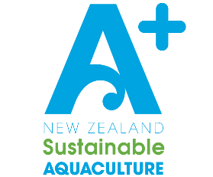
Community & Environment Engagement Record
Enter all engagement events in this register. Can include all voluntary interactions with external groups and places.
Examples of entries include, but are not limited to: Beach clean-ups, Community working groups & consultations, planting days, school fairs, regional council meetings, Conferences, festivals, School visits, community tours of farms, Hosting representatives, recruitment fairs, careers expos, Presentations to community groups, ecological restoration projects, etc
Company Name:
Year:

Engagement Details:
Date Received: | E.g. 12.02.2020
Event / Programme Type: | E.g. Beach clean-up, Careers expo, Council hearing, etc
Location: | E.g. Sandy Bay, Sanderson School, MRC offices, etc
People / Groups Involved: | E.g. Sanderson school year 9, AQNZ, MRC, General Manager Sandy Sanderson, etc
Event / Programme Description: | E.g. Completed beach clean of sandy bay with yr 9 group and provided 1hr lesson on mussels, 2 staff members attended careers expo with stand about mussels, General manager Attended hearing about proposed resource consent changes and made submission, etc

Engagement Details:
Date Received:
Event / Programme Type:
Location:
People / Groups Involved:
Event / Programme Description:

Engagement Details:
Date Received:
Event / Programme Type:
Location:
People / Groups Involved:
Event / Programme Description:

