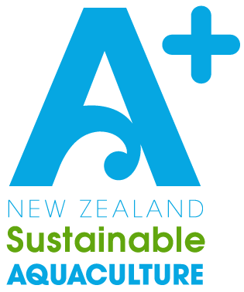

A+ Wildlife

Management Plan

Company Name: [Insert company name here]

Consent Numbers: [Insert relevant consent numbers here]

Message from AQNZ
This A+ template is designed to be adapted to your particular marine farms and operations. Key sections for your input are marked with [red].
Please delete any template instructions on your final version.
If you receive any feedback or required changes from your consenting authority in response to this management plan, please pass this on to AQNZ so we can continually improve our template.

Version | Date | Description | Authorised | Reviewer
1 | 01/22 | Draft v1 | C Gilbertson (AQNZ) | D Taylor (AQNZ)
[Delete the entries above and add in your own entries for management of your version of this document – entries above are examples]

Contents
Purpose 3
Scope & Background 4
Resources & References 5
Potential Interactions with Wildlife 6
Likely Wildlife in Farmed Areas 7
Marine Mammals: 7
Birds: 11
Best Practice 13
A+ Sustainable Management Framework 14
Response Procedures 15
Operational Staff Training 15
Monitoring and Recording – Presence & Incidents 15
Document Life 15
Appendices 16
A1 - Marine Mammal Incident Report 16
A2 - A+ Marine Mammal Response Standard Operating Procedure 17
A3 – General Boating Protocol 18

Purpose
The purpose of this Wildlife Management Plan (WMP) is to minimise the risk of potential adverse interactions of marine wildlife with activities related to the marine farm including stock, structures, equipment, and vessels.
This document is designed to be used in conjunction with external wildlife identification resources, such as the DOC marine mammal and seabird ID guides.

This WMP relates to the following consent conditions:
[Insert relevant council consent condition or reference NESMA. If not a consent requirement, simply write N/A]
•

The relevant matters of discretion in the National Environmental Standard for Marine Aquaculture (2020) to this WMP are:
Regulation 18:
(h) management practices to minimise adverse interactions between marine mammals or seabirds and the marine farm, including entanglements, injury, and mortality.
(l) information, monitoring, and reporting requirements.
Regulation 20:
- For replacement coastal permits for offshore marine farms under this Part, an additional matter of discretion is the adverse effects of the entanglement of large whales.

Scope & Background
Marine farmers recognise the coastal environment is a shared resource with high biodiversity and social values. When operating a marine farm, farmers strive to do everything possible to not disturb wildlife on and around marine farms, and ensure all steps are taken to minimise the risk of adverse interactions between marine mammals and marine farms.
All New Zealand marine mammals are protected under the Marine Mammals Protection Regulations 1992 and the Marine Mammals Protection Act 1978. All other New Zealand marine wildlife including seabirds are protected under the Wildlife Act 1953.
It is the policy of this Company that all marine farm staff must comply with this Marine Wildlife Management Plan.
This Marine Wildlife Management Plan applies to the following farms:
Farm Consent Number | Farm Description / Location
[List Farms] | [E.g. Land based RAS, Catherine Cove sea pens, etc]

Farm Maps:
[Insert maps showing farm locations]

Resources & References
The below resources have been used to inform the information, guidelines, and protocols outlined in this Marine Wildlife Management Plan.
- DOC Seabird ID guide - https://www.doc.govt.nz/globalassets/documents/conservation/marine-and-coastal/fishing/fishers-guide-nz-seabirds.pdf
- DOC Shorebird Species Guide - https://www.doc.govt.nz/globalassets/documents/conservation/native-animals/birds/sea-and-shore/whats-that-shorebird-brochure.pdf
- DOC Whale ID Posters - https://www.doc.govt.nz/globalassets/documents/conservation/native-animals/marine-mammals/whale-id-posters-web.pdf
- DOC Marine Mammal ID Flip Cards – https://www.doc.govt.nz/globalassets/documents/conservation/native-animals/marine-mammals/whale-id-flip-cards-web.pdf
- DOC Marine Mammal Sighting Reporting Guide - https://www.doc.govt.nz/globalassets/documents/conservation/native-animals/marine-mammals/have-you-seen-marine-mammals.pdf
- DOC Behaviour around Marine Mammals Guide - https://www.doc.govt.nz/globalassets/documents/conservation/native-animals/marine-mammals/marine-mammal-regulations-summary.pdf
- DOC Marine Mammal Ranges and Breeding Grounds Poster - https://www.doc.govt.nz/about-us/science-publications/conservation-publications/native-animals/marine-mammals/marine-mammals-of-nz-poster/
- DOC Marine Mammal Conservation Status Guide - https://www.doc.govt.nz/globalassets/documents/science-and-technical/nztcs29entire.pdf
- NZ Birds Online – Bird Encyclopaedia – https://nzbirdsonline.org.nz/
- MPI (2013). Literature Review of Ecological Effects of Aquaculture. Chapter 4. Effects on Marine Mammals (authored by D. Clement, 2013). https://www.mpi.govt.nz/dmsdocument/3752-Literature-Review-of-Ecological-Effects-of-Aquaculture-Chapter-4-Effects-on-Marine-Mammals
- Chapter 6. Seabird interactions (authored by P. Sagar, 2013) https://www.mpi.govt.nz/dmsdocument/3754-Literature-Review-of-Ecological-Effects-of-Aquaculture-Chapter-6-Seabird-Interactions

Potential Interactions with Wildlife
The potential interactions of marine mammal wildlife with Aquaculture farming operations are described below. [If there are additional potential effects relating to your specific farming practices make sure you add them here – included are just the potential effects relevant to most aquaculture]
Potential Interaction | Summary of potential effect(s) | Comment
Entanglement | Physical interactions between aquaculture and marine mammals can lead to an increased risk of entanglement. The risk of entanglement increases as wildlife tends to be attracted to associated schools of fish.  Diving birds can become entangled in loose underwater nets and drown. In addition, birds can become entangled in above-water nets used to exclude potential predators (such as seabirds and marine mammals), resulting in injury to wings and/or legs, and in some cases death. | Effects vary depending on the species status and population range.  All entanglements will be reported in A+ and to DOC as per their recommendations.
Underwater Noise Disturbance | Underwater noise associated with regular, ongoing farm activities (including vessels) may either exclude or attract marine mammals. Whales and particular dolphin species tend to be more sensitive to such disturbances, while pinnipeds and other dolphin species (such as common and bottlenose dolphins) may be attracted to the novel noise source. | Whales and particular dolphin species tend to be more sensitive to underwater noise, while pinnipeds, common and bottlenose dolphins may be attracted to the noise.
Ingestion of Foreign Objects from Aquaculture | Impairment of the digestive tract of seabirds through the ingestion of non- biological waste originating from farms. | Can be controlled through waste management practices that minimise potential for rubbish from farms to end up in the sea.
Information retrieved from: MPI (2013). Literature Review of Ecological Effects of Aquaculture. Chapter 4. Effects on Marine Mammals (authored by D. Clement, 2013) and Chapter 6. Seabird interactions (authored by P. Sagar, 2013).

Likely Wildlife in Farmed Areas
Below are lists of marine wildlife that relate to farm locations covered by this Wildlife Management Plan. Relevant species info has been sourced from the DOC Marine Mammal and Seabird ID guides (see Resources p5). [Using the species resources, update these tables to reflect the species that may be encountered at any farm sites covered by this WMP. Staff training should include identification and operating/reporting requirements for any threatened species]
This section will vary largely between farmers so you will need to update it to reflect your own farm sites and operations. Some images have been added – make sure that images relevant to your farming operations are included for help with identification.
Marine Mammals: [Example table entries below – edit these to include all relevant species]
Common name | Scientific name | Status | Associated Farm Areas
Common dolphins | Delphinus delphis | Not Threatened | E.g. First of Thames, Mahurangi Harbour, Banks peninsula, etc
Short-Beaked Common Dolphins have a sleek body, dark upper and dorsal fin, tan or yellow sides, distinctive criss-cross or hour-glass type pattern centred on the flanks and a creamy or white belly. The dorsal fin is high with a concave hind edge. The head is low and smooth-sloping.
Bottlenose dolphins | Tursiops truncatus | Nationally Endangered
Bottlenose Dolphins have a relatively short beak and a hooked, prominent dorsal fin. They are dark or light grey on the back grading to white on the undersides, although their colour and shape can be variable. The size of a new-born is around 85 cm to 1.3 m in length, and an adult 1.9 to 3.9 m.
Orca | Orcinus orca | Nationally Critical
Bryde’s whales | Balaenoptera edeni brydei | Nationally Critical
Bryde’s whales can be distinguished from other similar looking whale species due to the three long ridges on the top of their heads.
Southern right whales | Eubalaena australis | At Risk: recovering
Southern right whales are mostly black in colour and can easily be identified by lack of a dorsal fin, a V-shaped blowhole spray and white growths on their heads called callosities.
New Zealand fur seal | Arctophoca forsteri | Not threatened
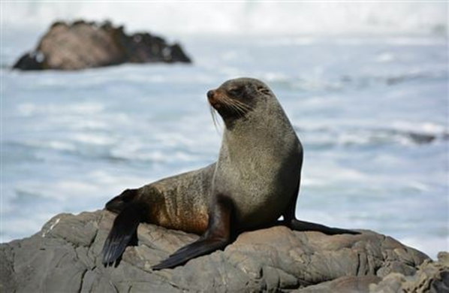
Dusky dolphin
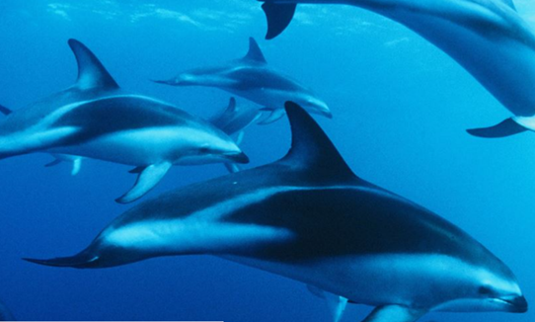
Dusky dolphins have virtually no beak, and their dorsal fin is not hooked and rather blunt. They are a bluish-black colour on the back and tail and white on the underside of the body.
Hectors Dolphin
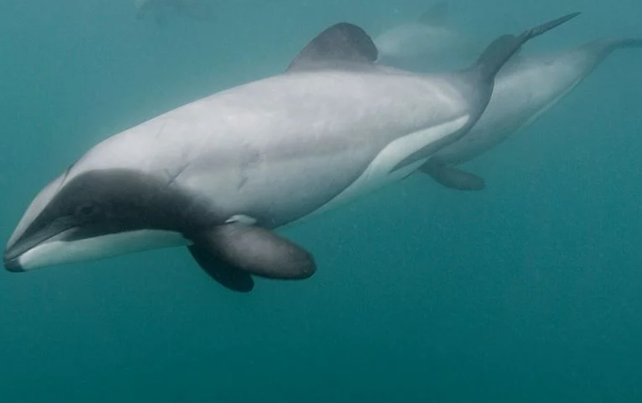
Hector’s dolphins have a distinctive rounded dorsal fin that looks like one of Mickey Mouse’s ears. Their bodies are grey with black and white markings. They look the same as Māui dolphin.
Maui Dolphin
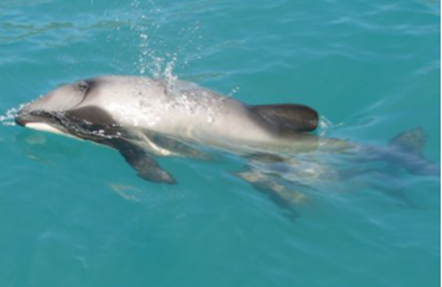
Māui dolphins have a distinctive rounded dorsal fin that looks like one of Mickey Mouse’s ears. Their bodies are grey with black and white markings. They look the same as Hector’s dolphin.
New Zealand sea lion | Phocarctos hookeri | Nationally Vulnerable
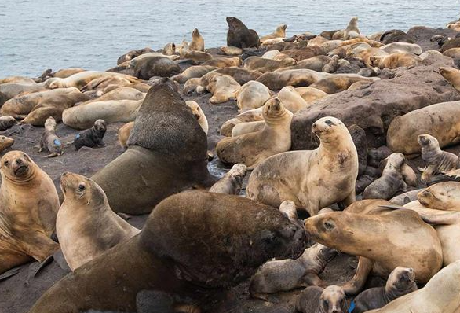
Blunt nose. Males: up to 3.5m, 250-400kg, dark brown fur. Females: up to 2m, 100-160kg, honey-coloured fur. Mostly found in Southern NZ.

Birds: [Example table entries below]
Common name | Scientific name | Status | Associated Farm Areas
King Shag | Leucocarbo carunculatus (Gmelin, 1789) | Nationally Endangered | E.g. First of Thames, Mahurangi Harbour, Banks peninsula, etc
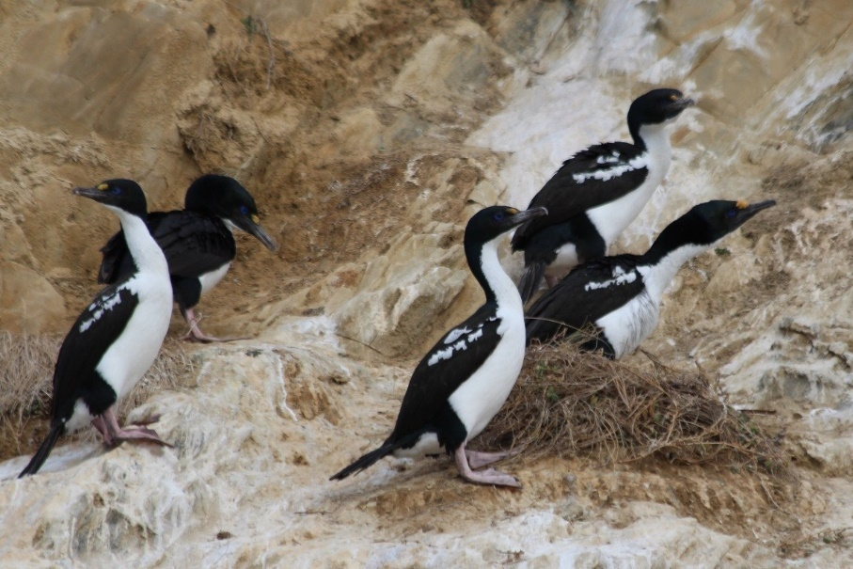
• large shag (76 cm in length) • dark head with blue eye ring • facial skin turns bright red during the breeding season • dark bill with an orange spot at its base • white throat and belly with dark upper body • dark wings with some white bar markings • pink feet • similar in appearance to Chatham Island shag and pied morph of Foveaux and Otago shags
Black Billed Gull | Chroicocephalus bulleri (Hutton, 1871) | Declining
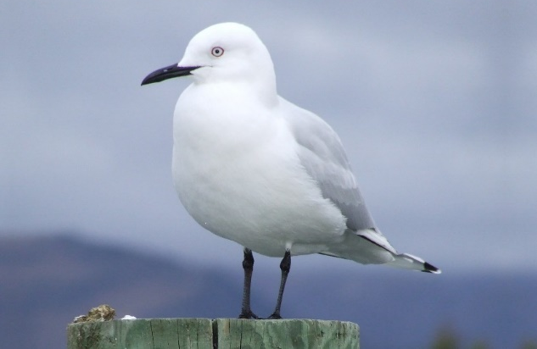
• small gull (35-38 cm in length) • white head and body • long, thin black bill • wings are grey on top with narrow black tips and white underneath • dark legs and feet • similar size and colouring to red-billed gulls, but the black-billed gull is paler, with less black on the wing tips • adults are easily distinguished by bill colour
Caspian Tern | Hydroprogne caspia | Nationally Vulnerable
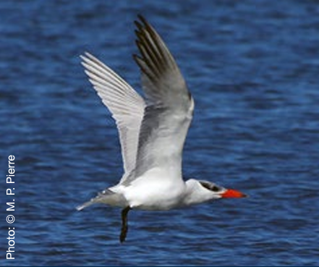
World’s largest tern (47–54 cm in length) • white body and lower half of head • distinctive black cap on top half of head during breeding • upperwings silver-grey • underwings white with charcoal-grey primary feathers • massive, orange-red bill with black tip • black legs and feet

Best Practice
There are a range of management and mitigation options to minimise the likelihood of adverse interactions between marine wildlife and marine farms MPI (2013). Key mitigation measures include:
- Regular maintenance of farm structures, including keeping lines secured and anchor warps and nets under tension.
- Ensure any non-biological waste and debris is collected and disposed of correctly.
- Observing marine wildlife species interactions with the farm.
Best practice management and procedures to minimise the risk of adverse interactions as per current local government, DOC, and MPI guidelines are detailed below. [NB: Include any additional best practice procedures relevant to your own consent conditions and/or farming operations]
 | Procedures
General | If any marine wildlife is seen in the marine farm:  - Keep watch for any entanglements.  - Do not disturb, harass, or feed the wildlife.  - If marine mammals are seen, avoid making loud noises where possible.  - Let any marine mammals move out of the area of their own accord – do not chase them.
Structures & Equipment | Well maintained structures and equipment should minimise risk of entanglement of wildlife:  - Keep farm structures and equipment free of loose floating lines, nets, or ropes.  - Marine farming anchor warps, lines and ropes must be kept taut.  - Loose anchor warps, lines, nets, and ropes must be secured and/or retrieved promptly.  - Any loose anchor warps, lines, or ropes that must remain in the water must be buoyed off by the way of a header float. This is required to ensure that the length of line through the water column remains as taut and vertical as possible, with the minimum amount of slack line. Slack line on the surface should also be minimised.  - Regular maintenance checks of structures.  - Any structural damage must be repaired as soon as practicable.
Vessels | - In transit - vessel keeps at least 300m from any observed marine mammals.  - When operating in a farm, move only at idling speed if any marine mammals observed.  - Vessels avoid travelling within 100m of bird colonies.  Refer Appendix 3
Entanglement & Other Incidents | - Ensure non-biological wastes are safely and appropriately disposed of to minimise the risk of attraction and entanglement.  - Record all entanglements and report all notifiable incidents as per relevant regulatory requirements.  - Report any marine mammal entanglements to DOC as soon as possible.  Refer Appendix 1 & 2
Recording Presence of Marine Mammals | Additional reporting of mammal presence is beneficial where practicable to place interactions in context. Some additional recording may be required under your consent conditions.  - When possible or practical, record any marine mammal species observed in the vicinity or general region of the farm site. In observations of any time spent under or around the farm structure.

A+ Sustainable Management Framework
Marine farmers are encouraged to participate in the Aquaculture New Zealand’s A+ Environment Programme. A+ is an improvement programme that provides New Zealand marine farmers with the practical tools to demonstrate transparency around their environmental performance with annual checklists that are completed by the grower.
The objectives of A+ align with those of world leading accredited certification programmes - such as Aquaculture Stewardship Council (ASC) and Best Aquaculture Practice (BAP). This association further substantiates the importance we place on our role as outstanding guardians of our place and people.
The framework formalises a cycle of continuous reporting, review, and improvement, and provides a great platform for the community and industry to engage on their sustainability aspirations.
The purpose of the Sustainable Management Framework (SMF) is to promote the sustainable management of aquaculture in New Zealand by providing guidance for best environmental and social practice for the industry.
The aim of the SMF is to achieve the following:
- Facilitate best environmental practice through research, risk management, ongoing monitoring and reporting and promotion of continuous improvement.
- Promote a culture of environmental stewardship that supports and enhances clean waters and functioning natural ecosystems.
- Communicate our environmental and social performance to address community concerns and increase support for the industry and to demonstrate the advantages of our products on the international market.

Response Procedures
Standard operating procedures for marine mammal incidents attached as Appendix 2.
You may require additional SOPs for protocols relevant to your farming practices or consent conditions. Add them here.

Operational Staff Training
[Edit this list to reflect what you have included in your staff training SOP – OR – Alter this section to simply include the SOP entirely.]
All staff and contractors operating in areas where wildlife is present are trained in the following skills and knowledge:
- Understanding of this document – the Wildlife Management Plan
- Incident and Interaction reporting requirements and procedures
- Wildlife identification training on key species relating to your farming practices
- Wildlife incident response best practice
Staff training will be undertaken as part of staff induction and reviewed regularly to ensure it is up to date and reflects current best practice.

Monitoring and Recording – Presence & Incidents
All wildlife incidents or sightings are recorded using our Wildlife Incident register, Location: [enter where this can be found]
AQNZ have a wildlife register that you can use or adapt to your requirements or preferences HERE.
Wildlife incidents and interactions are recorded and reported as per consent requirements, listed below: [Insert relevant council consent conditions. If not a consent requirement, simply write N/A]

Document Life
This Wildlife Management Plan shall be reviewed every five years or within 2 months of a marine mammal entanglement and updated to ensure best practice management [Edit to reflect council requirements as appropriate – above example reflects Waikato council requirements]. As part of the review the collated monitoring information shall be assessed and used to inform appropriate changes to farming practices, record keeping, or company policy around wildlife management.
[Enter here any document requirements specified by your resource consent or additional information about the protocol around this document].

Appendices

A1 - Marine Mammal Incident Report
In the event that an entangled, stranded, deceased, or injured marine mammal (e.g. whale, dolphin, seal, sea lion, etc) is found, OR if there is any direct interaction or contact between any company vessels, marine farms, or persons with a marine mammal, complete the following report.
This marine mammal incident report is to be completed as soon as practical and kept for company records and logged in an incident register.
Company Name and Vessel
Date & Time of Incident
Witnesses or Persons Involved | Name:  Number:  Name:  Number:
Type & Number of Marine Mammals Involved
Location & GPS Coordinates
Photo Evidence & location | (Evidence is recommended wherever possible and safe to achieve – include where this evidence is stored so it can be retrieved)
Details of Incident
Actions Taken (if any)
Signed

A2 - A+ Marine Mammal Response Standard Operating Procedure
If an entangled / stranded / deceased or injured marine mammal (whale / dolphin / seal / sea lion) is found, or if there is any direct interaction or contact between any company vessels, marine farms, or persons with a marine mammal, the following steps must be taken:
[This SOP should be updated to reflect the specifics of your farming regions, consent conditions, and farming operations. If you already have an SOP for wildlife incidents, upload it here.]
ENTANGLEMENT
DO NOT UNTANGLE, ATTEMPT TO ASSIST, OR MOVE THE MARINE MAMMAL under any circumstances.
INCIDENT PROCEDURE
Immediately phone your company manager and local Department of Conservation representative. Contact Details:
Company Manager name: [insert] Phone number: [insert]
Local DOC representative name: [insert] Phone number: [insert]
Or DOC Hotline 0800 362 468
Procedure:
- Immediately note details listed on your incident report sheet (e.g. time, date, description, location, photos, people, etc)
- Contact DOC and follow advice for next steps
  - DOC may wish to investigate further (entanglement)
  - DOC may advise for company to take further action
- Add the incident to your Wildlife Incident & Interactions Register (may be completed later once incident is dealt with)
REPORT ALL SIGHTINGS OF STRANDINGS, SOUTHERN RIGHT WHALE, OR MĀUI DOLPHIN.
You can report sightings of whales to DOC conservation hotline 0800 DOCHOT (0800 362 468). You can also report a sighting online. https://www.doc.govt.nz/nature/native-animals/marine-mammals/marine-mammal-sightings/marine-mammal-sighting-form/ Reports of sightings are valuable and help increase knowledge of whale distribution and movements.
Record the details, with as much information as possible with your sighting:
- the date, time and location (GPS coordinates if possible)
- the number of whales and whether any are calves
- the direction they were travelling
- take photographs or video; focus on identifying marks, the left side of the head, and shots of the full length of the body.

A3 – General Boating Protocol
Whilst sharing water space with marine mammals, all vessels and personal must adhere to the DOC guidelines:
