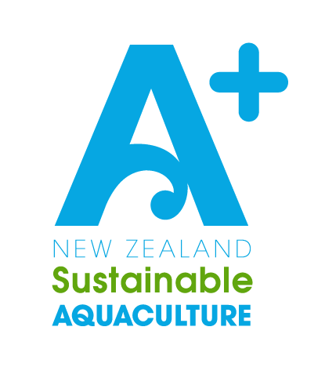



**Biosecurity**

**Management Plan**

**Greenshell™ Mussels (GSM)**

Company Name: [Insert company name here]

Consent Numbers: [Insert consent numbers covered by this BMP here]

Message from AQNZ

This A+ Biosecurity Management Plan template is designed to be adapted to your particular marine farms and operations. Key sections for your input are marked with [red].

Please delete any template instructions or irrelevant sections on your final version.

If you receive any feedback or required changes from your consenting authority in response to this management plan, please pass this on to AQNZ so we can continually improve our template.

*Note: This template can be adapted for other non-feed added farmed species such as seaweed and other subtidal shellfish.*

|  |  |
| --- | --- |
| **Farm Manager or Other Staff Responsible for Biosecurity:** | |
| **Name:** | **Phone / Contact Info:** |
| [Insert Biosecurity Staff details here] |  |
|  |  |
|  |  |
|  |  |

**Prepared by:** Dr David Taylor (AQNZ), Robin Britton (Resource Management Consultant), Steph Hopkins (AQNZ), Tom Hollings (CMFA), Ned Wells (MFA), Caroline Gilbertson (AQNZ).

*This document should be reviewed annually to ensure it remains up to date against biosecurity legislation and best practice in New Zealand Aquaculture.*

|  |  |  |
| --- | --- | --- |
| **Date Last Amended / Reviewed** | **Person(s) Involved** | **Description of Changes / Review** |
| 23/08/23 | D Taylor, C Gilbertson | Updates to Bonamia and Caulerpa CAN maps & Management Area details |
|  |  |  |
|  |  |  |
|  |  |  |
|  |  |  |

Table of Contents

1. Purpose 4

2. Background 5

2.1 Biosecurity Contacts 5

2.2 Roles 6

2.3 National Operational Zones 6

2.4 Biosecurity Management Areas 7

3. Relevant Operational Zones and Management Areas 8

3.1 The Top of the North 8

3.2 The Top of the South 9

3.3 Canterbury 11

3.4 Lower South 12

3.5 Chatham Islands 14

4. A+ Sustainable Management Framework 16

5. Knowing the Risk 16

5.1 Biosecurity Risk Species by Location 16

5.2 Further Information on Notifiable Organisms 17

5.3 Pathways 18

6. Managing Biosecurity Risk – Best Practice Outline 19

6.1 People & PPE 19

6.2 Inspections 20

6.3 Stock 20

6.4 Equipment 22

6.5 Vessels & Vehicles 23

6.6 Waste / Disposal 24

7. Reporting Procedures for New Disease / Species Detected 25

8. Training 25

8.1 Farm Manager or Biosecurity Representative: 25

8.2 General Staff: 26

8.3 Contractors: 26

9. Recording, Reporting, and Review 27

APPENDIX 1: Potential Pest Pathway Assessment 28

APPENDIX 2: Operational Procedures and Recording 30

APPENDIX 3: Report Form for New Marine Pests and / or Diseases 32

APPENDIX 4: Biosecurity Event Contingency Plan 33

APPENDIX 5: Sampling Kit & Process 35

## Purpose

**The A+ Greenshell™ Mussel Biosecurity Standards guide the development of Biosecurity Management Plans (BMP’s), provide a national approach to marine biosecurity, and identify high risk pathways and potential controls for those risks (**[**https://www.aquaculture.org.nz/resources/general**](https://www.aquaculture.org.nz/resources/general)**).**

The purpose of this BMP is to comply with the A+ Biosecurity Standards and in doing so, minimise the risk to our growing environment and our businesses from introducing and spreading disease, unwanted marine organisms, or pest species.This BMP alsoaddresses the requirements of the National Environmental Standard for Marine Aquaculture (NES-MA) 2020,the Biosecurity Act 1993, the Fisheries Act 1996, and any consent requirements under the Resource Management Act 1991 (RMA).

Aquaculture New Zealand (AQNZ), who coordinate the A+ environmental programme, joined the Government Industry Agreement (GIA) for Biosecurity in 2019. Readiness and response activities relevant to aquaculture are managed under the GIA. AQNZ are committed to having all members working under a BMP by the end of 2024, as required under the A+ programme Biosecurity Standards and Sustainable Management Frameworks.

The A+ Greenshell**™** Mussel Biosecurity Standards are reviewed every two years to ensure that industry continues to align with best practice.

**For the farm sites covered by this plan, the resource consent condition(s) relating to biosecurity management is /are:**

[**List relevant consent conditions here**]

* A
* B
* C

## Background

Marine farmers recognise they have a role in the management of biosecurity risks. Biosecurity management is an essential part of the day-to-day operations on a marine farm. This Company will always strive in all respects to minimise the biosecurity risk arising from introductions and/or spread of unwanted pests and notifiable organisms (including pests and pathogens) arising from the Company’s farming operations.

However, it is also recognised that the control of biosecurity risks is a shared responsibility of all marine stakeholders including the marine farmer, other commercial operators, recreational boat owners, other marine farmers, local authorities (Councils), Iwi and Government (Ministry for Primary Industries - Biosecurity New Zealand).

|  |
| --- |
| **It is the policy of this Company that all operational farm staff must comply**  **with this Biosecurity Management Plan.** |

### 2.1 Biosecurity Contacts

Below are some of the key contacts relating to aquaculture biosecurity management throughout NZ. Make sure these are up to date and that all appropriate contacts for your farm areas are included whenever reviewing your BMP.

|  |  |  |
| --- | --- | --- |
| **Contact** | **Name** | **Details** |
| MPI / Biosecurity NZ Pest and Disease Hotline | Marine Incursion Investigator | 0800 80 99 66 |
| Top of the North Biosecurity Co-ordinator | Dave Taylor | 021 677 119 |
| Top of the North Biosecurity Partnership | Bay of Plenty Regional Council | <https://www.marinepests.nz/> |
| Top of the South Biosecurity Co-ordinator | Ned Wells | 03 578 5044 |
| Top of the South Marine Biosecurity Partnership | Peter Lawless | 021 894 363 |
| Aquaculture NZ Technical Director (Biosecurity) | Dave Taylor | 021 677 119 |
| MPI online Tool for reporting suspected pests |  | [https://report.mpi.govt.nz/pest/](https://apc01.safelinks.protection.outlook.com/?url=https%3A%2F%2Freport.mpi.govt.nz%2Fpest%2F&data=04%7C01%7Ckaren.morley%40aquaculture.org.nz%7C239553eef2b54bb7827408da0b98a446%7C74375a54cc8a47d692dc13e857a80585%7C0%7C0%7C637835047461835207%7CUnknown%7CTWFpbGZsb3d8eyJWIjoiMC4wLjAwMDAiLCJQIjoiV2luMzIiLCJBTiI6Ik1haWwiLCJXVCI6Mn0%3D%7C3000&sdata=8K2YQ7lBgL99d8vWyJ%2FaWcqYWtCowedXF%2FOGdm4Kjws%3D&reserved=0) |
| Marine Pest ID website |  | marinepests.nz/marine-pest-id |
|  |  |  |

### 2.2 Roles

In terms of this Biosecurity Management Plan, the following have key roles:

* **Ministry for Primary Industries (MPI):** The Biosecurity Act 1993 is implemented by Fisheries NZ. This Act requires that any suspected unwanted organisms, and all significant diseases and abnormal/high mortality rates to be **reported to the** **MPI Hotline 0800 80 99 66**.
* **Regional Councils:** Councils are responsible for the implementation of the Biosecurity Act 1993 (through biosecurity plans) and the Resource Management Act 1991 (through resource consents and plans).
* **Aquaculture New Zealand (AQNZ):** AQNZ has a national role that acknowledges the importance of reducing risks and keeping industry players informed. In this context, the A+ Sustainable Management Framework and Industry Biosecurity Standards are key methods for delivery.

|  |
| --- |
| **Additional resources to manage biosecurity risk:**  **AQNZ has prepared additional information on biosecurity management and marine farmers have access to this information and to advice on improving procedures over time:** <http://www.aplusaquaculture.nz/biosecurity> |

### 2.3 National Operational Zones

**Operational Zones** (Figure 1) were formed by the NZ aquaculture industry to ensure a national approach to marine biosecurity risk under the A+ New Zealand Greenshell™ Mussel Biosecurity Standards. Operational Zones where marine farming currently occurs include: Top of the North, Top of the South Island, Canterbury, and Lower South.

Operational Zones are generally aligned with Biosecurity partnership areas identified by regional councils. The Top of the North Biosecurity Partnership covers Northland, Auckland, Waikato and Bay of Plenty Regional Councils and aligns with the Top of the North Operational Zone. The Top of the South Operational Zone roughly aligns with the Top of the South Marine Biosecurity Partnership, which includes Tasman District Council, Nelson City Council and Marlborough District Council.

**Figure 1:** NZ Aquaculture Industry Operational Zones

### 2.4 Biosecurity Management Areas

Within each Operational Zone, **Biosecurity Management Areas** are identified to distinguish those areas that warrant or require additional biosecurity measures.

Management Areas are identified based on the following criteria:

1. Industry agreement (e.g., under a Management Area Agreement);
2. Regional and national statutory biosecurity requirements (e.g., Controlled Area Notices, Regional Pest Management Plans, which may include policies and rules related to the management and control of marine biosecurity risks);
3. Differing “biosecurity status” (e.g., presence/absence of specific unwanted organisms);
4. Higher risk of introduction and spread of unwanted organisms (e.g., presence of an international port or point of entry marina, international large vessel anchoring site, or known higher risk area (e.g., Great Barrier Island).

## Relevant Operational Zones and Management Areas

This section contains details about the different management areas specified for each operational zone. Delete all sections that are not relevant to your specific farming operations. Any zone that you move stock or farming equipment into or out of should be included in this BMP. **Staff training should include understanding the details outlined in this section**.

### 3.1 The Top of the North

**The Top of the North Operational Zone (TNOZ) boundaries** include all space within and northward of the Waikato and Bay of Plenty Regions (Figure 2). The main GSM growing areas within the TNOZ are Coromandel, Auckland, and Bay of Plenty.

Within the TNOZ, the following special **Management Areas** (Refer Figure 2) have been identified and have additional biosecurity requirements applied to them:

**Waikato Region:**

* **East Coast Coromandel:** This area does not currently have some of the pest species present in other parts of the Waikato region.
* **Aotea Harbour:** This area is a critical spat collecting area and does not currently have some of the pest species present in other parts of the Waikato region.

**Northland Region**[1]

* Northland Regional Council has identified Management Areas (called marine designated areas) in their Regional Pest Management Plan (RPMP) and each of these areas has different marine pest profiles.
* **Te Rāwhiti Inlet**, as of June 2023, a Controlled Area Notice is in place to control the spread of invasive *Caulerpa* sp[2]. It imposes anchoring, fishing, and diving restrictions. Mana whenua have laid a rāhui on the area with the same restrictions. Although there are no marine farms in the area, marine farmers in the Bay of Islands should remain vigilant and report any suspected sightings in farm areas.
* **Te Oneroa-a-Tōhē (Ninety Mile Beach**) is a nationally significant spat collecting area.
* **Whangape Harbour:** This area is a critical spat collecting area in Northland and does not currently have some of the pest species present in other parts of the Northland region.

**Auckland Region**

* **Great Barrier Island** is a high-risk area for exotic marine pests [3]
* **Auckland Council - Hauraki Gulf Controlled Area:**  covers all the Hauraki Gulf within the Auckland region[4].

**Bay of Plenty Region**[5]

* **Ōpōtiki (Bay of Plenty):** Bay of Plenty Regional Council has identified Management Areas (called pest incursion zones) in their Regional Pest Management Plan and have specific rules relating to clean hulls on vessels and the movement of aquaculture equipment (including ropes and floats) in and out of these areas.

**Figure 2:** TNOZ Management areas

### 3.2 The Top of the South

**The Top of the South Operational Zone (TSOZ) boundaries** are from the NW boundary of Southland to Northern of Taranaki regional boundary over to the NE Manawatu – Wanganui regional boundary and down to the SE Marlborough boundary at Clarence). The main GSM growing areas within the TSOZ are Golden and Tasman Bays and the Marlborough Sounds (including Port Underwood).

**TSOZ Management Areas:**

Within the TSOZ, the following **Management Areas** (Figure 3) have been identified and have additional biosecurity requirements applied to them:

**Nelson / Tasman Region:**

* **Wainui:** This area is a critical spat collecting area and does not currently have some of the pest species present in other parts of the Operational Zone.
* **Tarakohe harbour:** This harbour has pest species under ongoing management that are not present in other parts of TSOZ (e.g., Sabella).
* **Port Nelson and Nelson Marina:** This harbour and marina has pest species under ongoing management that are not present in other parts of TSOZ.

**Wellington:**

* **Wellington harbour:** This harbour has pest species under ongoing management that are not present in other parts of TSOZ.

**Marlborough:**

* **Pelorus Sound - Admiralty Bay**: is considered a higher-risk area for exotic marine pests as it has a large vessel anchoring site (this area is a candidate for additional surveillance)
* **Queen Charlotte Sound - Waikawa Marina:** This marina has pest species under ongoing management that are not present in other parts of TSOZ (e.g. Sabella).
* **Bonamia CAN in place –** a movement permit must be attained from MPI- BNZ for any shellfish not going to processing for human consumption out of the ‘Upper South Contained Zone’. For more details see: <https://www.mpi.govt.nz/dmsdocument/56899-Bonamia-CAN-2023>

The **Upper South Contained Zone** has the following control measures under the Bonamia CAN:

*Movement of shellfish, including waste:*

(1) Flat oysters, Pacific oysters, Green-lipped mussels, or Geoducks must not be moved out of the Upper South Contained Zone for the purpose of commercial processing unless a permit is obtained prior to the movement.

(2) Shellfish collected inside the Upper South Contained Zone must not be returned to the marine environment outside the Upper South Contained Zone.

(3) Waste from shellfish collected inside the Upper South Contained Zone must not be discharged into the marine environment outside of the Upper South Contained Zone.

*Movement of equipment:*

(4) Equipment (including marine farm equipment) must not be moved out of the Upper South Contained Zone unless it is visibly free of fouling.

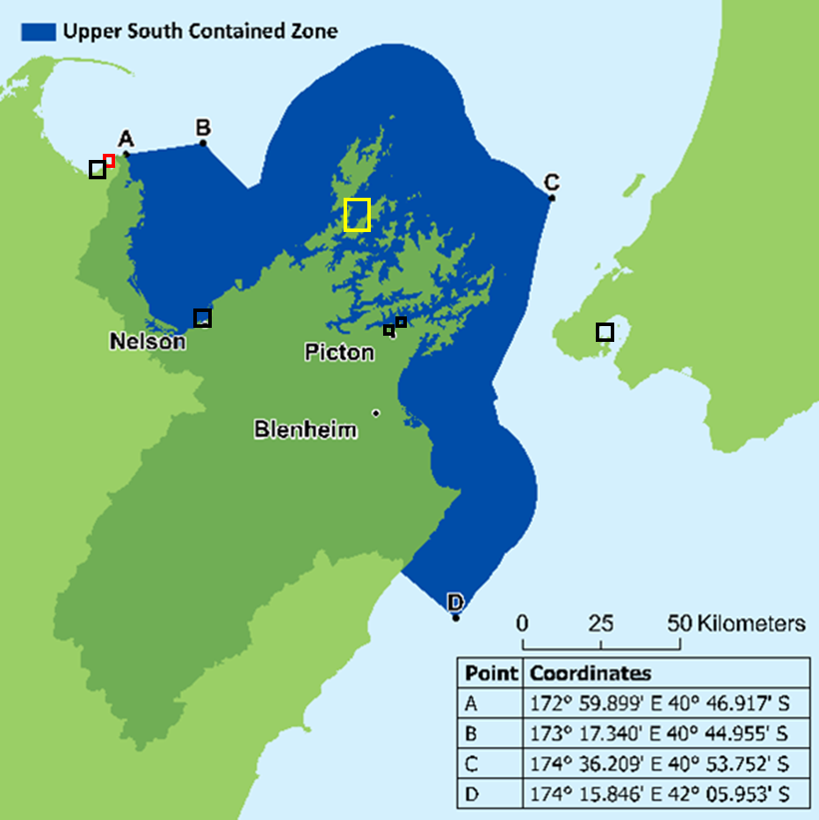

**Figure 3:** TSOZ Management Areas: **Orange** - Bonamia CAN ‘Contained Zone’, **Black** – high risk harbours and marinas, **Red** – Wainui Bay Industry Management Area, **Yellow** – large vessel anchoring – additional surveillance.

### 3.3 Canterbury

**The Canterbury Operational Zone boundaries** align with the Canterbury region. The main GSM growing areas within the Canterbury Operational Zone are Pegasus Bay, Banks Peninsula Bays and Akaroa Harbour.

The following Management Areas have been identified and have additional biosecurity requirements applied to them:

**Lyttleton Port** is a high-risk area for the introduction of marine pests and has pest species present that are under on-going management and are not currently on farms in the Zone (e.g Sabella).

<https://www.ecan.govt.nz/your-region/your-environment/our-natural-environment/pest-management/marine-pests/>

### 3.4 Lower South

**The Lower South Operational Zone boundaries** includes the Otago and Southland regions, including Stewart Island. The main GSM growing area in the Lower South is Big Glory Bay.

The following Management Areas have been identified in the Lower South Operational Zone and have additional biosecurity requirements applied to them:

**Bonamia CAN in place –** Movement Controls are in place for any shellfish and shellfish waste in the ‘Protected Zone’ (Figure 4) and the ‘Big Glory Bay Contained Zone’ (Figure 5). Movement Controls are in place for all marine farm waste, equipment and craft including but not limited to boats, rope, backbone line, droppers, mussel rope, marker buoys, navigation lights, anchor warps/lines.

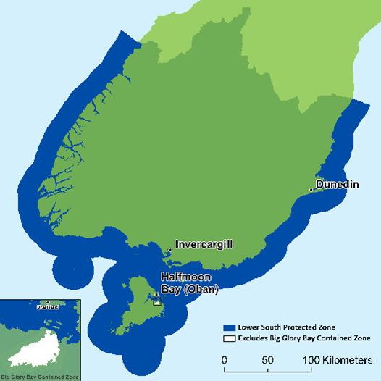

**Figure 4:** Lower South Management Area - Protected Zone under the *Bonamia ostreae* Controlled Area Notice 2021 (updated Sept 1st 2023). For more details see: <https://www.mpi.govt.nz/dmsdocument/56899-Bonamia-CAN-2023> and <https://www.mpi.govt.nz/biosecurity/exotic-pests-and-diseases-in-new-zealand/long-term-biosecurity-management-programmes/bonamia-ostreae-parasite-threat-to-flat-oysters/#can>

The **Lower South ‘Protected Zone’** has the following control measures:

*Movement of shellfish, including waste:*

(1) Flat oysters, Pacific oysters, Green-lipped mussels, or Geoducks must not be moved into the Lower South Protected Zone for the purpose of commercial processing unless a permit is obtained prior to the movement.

(2) Shellfish collected outside the Lower South Protected Zone must not be returned to the marine environment inside the Lower South Protected Zone.

(3) Waste from shellfish collected outside the Lower South Protected Zone must not be discharged into the marine environment inside the Lower South Protected Zone.

*Movement of equipment (including marine farm equipment):*

(4) Equipment (including marine farm equipment) must not be moved into the Lower South Protected Zone unless it is visibly free of fouling.

**Big Glory Bay is a ‘Contained Zone’** with the following control measures:

*Movement of shellfish, including waste:*

(1) Flat oysters must not be moved into or out of the Big Glory Bay Contained Zone.

(2) Pacific oysters, Green-lipped mussels, or Geoducks must not be moved into or out of the Big Glory Bay Contained Zone for the purpose of commercial processing unless a permit is obtained prior to the movement.

(3) Shellfish collected inside the Big Glory Bay Contained Zone must not be returned to the marine environment outside the Big Glory Bay Contained Zone.

(4) Waste from shellfish collected inside the Big Glory Bay Contained Zone must not be discharged into the marine environment outside the Big Glory Bay Contained Zone.

*Movement of craft (excluding marine farm craft):*

(5) Craft (excluding marine farm craft) must not be moved into or out of the Big Glory Bay Contained Zone unless:

(a) The craft is visibly clear of fouling; or

(b) if fouling is visible, a permit is obtained prior to the movement.

*Movement of marine farm equipment and marine farm craft:*

(6) Marine farm equipment must not be moved into or out of the Big Glory Bay Contained Zone unless a permit is obtained prior to the movement.

(7) Marine farm craft must not be moved into or out of the Big Glory Bay Contained Zone unless a permit is obtained prior to the movement.

*Movement of equipment (excluding marine farm equipment):*

(8) Equipment (excluding marine farm equipment) must not be moved into or out of the Big Glory Bay Contained Zone unless it is visibly free of fouling.

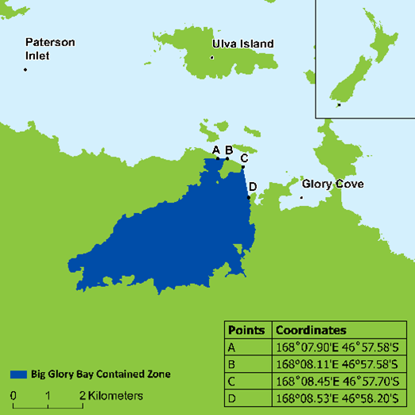

**Figure 5:** Big Glory Bay ‘Contained Zone’ under the *Bonamia ostreae* Controlled Area Notice 2021 (amended Sept 1st 2023). <https://www.mpi.govt.nz/dmsdocument/56899-Bonamia-CAN-2023>

### 3.5 Chatham Islands

The Chatham Islands Operational Zone covers all territorial sea surrounding the Chatham Islands. The Chatham Islands Council Pest Management Plan[6] has exclusion rules relating to *Eudistoma elongatum, Styela clava, Sabella spallanzanii,* and *Charybdis japonica.* There is currently no marine farming occurring in this Operational Zone but there is growing interest in developing this industry on the Island[7]. If this proceeds, Management Area controls will apply as a **Bonamia CAN** is also in place for the Chatham Islands**.** The CAN establishes a **‘Chatham Islands Protected Zone’** with the following control measures (<https://www.mpi.govt.nz/dmsdocument/56899-Bonamia-CAN-2023>):

*Movement of shellfish, including waste:*

(1) Flat oysters, Pacific oysters, Green-lipped mussels, or Geoducks must not be moved into the Chatham Islands Protected Zone for the purpose of commercial processing unless a permit is obtained prior to the movement.

(2) Shellfish collected outside the Chatham Islands Protected Zone must not be returned to the marine environment inside the Chatham Islands Protected Zone.

(3) Waste from any shellfish collected outside the Chatham Islands Protected Zone must not be discharged into the marine environment inside the Chatham Islands Protected Zone.

*Movement of marine farm craft and marine farm equipment:*

(4) Marine farm craft and marine farm equipment must not be moved into the Chatham Islands Protected Zone unless a permit is obtained prior to the movement.

*Movement of equipment (excluding marine farm equipment):*

(5) Equipment must not be moved into the Chatham Islands Protected Zone unless it is visibly free of fouling.

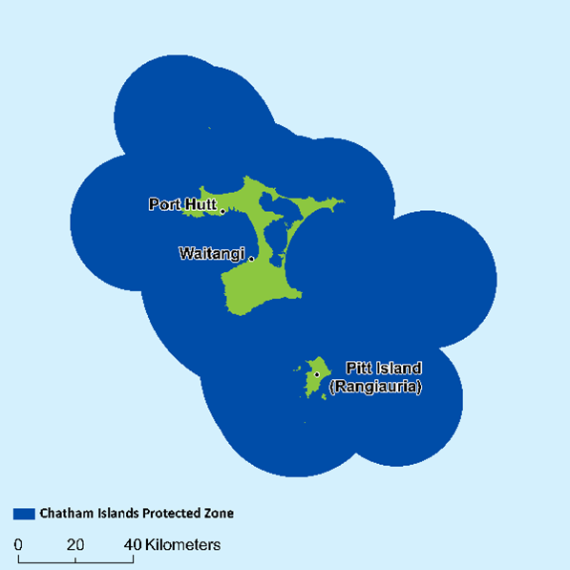

**Figure 6:** Chatham Islands ‘Protected Zone’ under the *Bonamia ostreae* Controlled Area Notice 2021 (amended Sept 1st 2023). <https://www.mpi.govt.nz/dmsdocument/56899-Bonamia-CAN-2023>

## A+ Sustainable Management Framework

Aquaculture farmers are encouraged to participate in the Aquaculture New Zealand’s A+ Environment Programme. A+ is an improvement programme that provides New Zealand aquaculture farmers with the practical tools to demonstrate transparency around their environmental performance with annual checklists that are completed by the producer.

The objectives of A+ align with those of world leading accredited certification programmes - such as Aquaculture Stewardship Council (ASC) and Best Aquaculture Practice (BAP). This association further substantiates the importance we place on our role as responsible guardians of our place and people.

The A+ Sustainable Management Framework (SMF) formalises a cycle of annual reporting and review for continuous improvement and provides a great platform for the community and industry to engage on their sustainability aspirations.

The purpose of the SMF is to promote the sustainable management of aquaculture in New Zealand by providing guidance for best environmental and social practice for the industry. More information can be found on the A+ website - <http://www.aplusaquaculture.nz/>

**Biosecurity in A+**

Biosecurity is a key section of the A+ Sustainable Management Framework. AQNZ, through an industry working group process, has developed the A+ Greenshell Mussel Biosecurity Standards and this Biosecurity Management Plan is designed to comply with these industry standards. The standards can be found at <http://www.aplusaquaculture.nz/biosecurity>

## Knowing the Risk

### 5.1 Biosecurity Risk Species by Location

Notifiable pests and diseases under the Biosecurity Act that are present in NZ by Operational Zone. You must notify MPI if these pests are observed in new locations.

|  |  |  |
| --- | --- | --- |
| ***Names*** | ***Site, Species or Region Detected*** | ***Additional Information*** |
| **Top of the North** | | |
| Mediterranean fan worm  (*Sabella spallanzanii*) | Auckland and Waikato | Hauraki Gulf Controlled Area Notice 2020 in place to reduce risk of spread to outer islands (e.g., Great Barrier Island): <https://www.aucklandcouncil.govt.nz/environment/what-you-can-do-for-environment/Documents/hauraki-gulf-can-2020.pdf>  Also trying to reduce risk of spread to industry Management Areas on West Coast North Island (e.g., Aotea Harbour) and Eastern Coromandel. |
| *Perkinsus olseni*  (shellfish parasite) | Confirmed in paua, mussels, scallops and other shellfish |  |
| *Caulerpa* species  *Caulerpa brachypus* and *Caulerpa parvifolia* | Great Barrier Island (Tryphena Bay, Blind Bay, Whangaparapara Bay), Great Mercury Island (Western Bays) | Controlled area notice in place:  <https://www.mpi.govt.nz/dmsdocument/47557-Exotic-Caulerpa-Controlled-Area-Notice-2022> |
| **Top of the South** | | |
| *Bonamia ostreae* (oyster parasite) | Nelson, Marlborough | Controlled Area Notice in place – stock movement permits required: <https://www.mpi.govt.nz/dmsdocument/44620-Bonamia-controlled-area-notice> |
| Mediterranean fan worm  (*Sabella spallanzanii*) | Port Tarakohe (Tasman), Port Nelson (Nelson), Waikawa Marina (Marlborough) | Small-Scale Management Programme in place for Top of the South: (e.g. <https://www.nelson.govt.nz/assets/Environment/Downloads/Water/sabella/NCC-Small-Scale-Management-Programme-for-Sabella-2017.pdf>) |
| *Perkinsus olseni*  (shellfish parasite) | Confirmed in mussels and other shellfish |  |
| **Canterbury** | | |
| Mediterranean fan worm  (*Sabella spallanzanii*) | Lyttleton Port | Industry Management Area control in place to reduce risk of spread to aquaculture facilities |
| **Lower South** | | |
| *Bonamia ostreae* (oyster parasite) | Southland (Big Glory Bay) | Controlled Area Notice in place: <https://www.mpi.govt.nz/dmsdocument/44620-Bonamia-controlled-area-notice> |

Other marine pests that are known to occur some Operational Zones and Management Areas including several ‘**unwanted organisms**’. The biosecurity controls detailed in this document are aimed at reducing the risk of exacerbating the spread of fouling organisms like:

* the clubbed tunicate (S*tyela clava*)
* Australian droplet tunicate (*Eudistoma elongatum*)
* Wakame (*Undaria pinnatifida*)
* Colonial Sea Squirt (*Didemnum vexillum*)

### 5.2 Further Information on Notifiable Organisms

**Further information on unwanted pests and notifiable organisms under New Zealand legislation:**

The National Biosecurity (Notifiable Organisms) Order 2016 can be found in this link: <https://www.legislation.govt.nz/regulation/public/2016/0073/9.0/whole.html>

Additional MPI information regarding unwanted pests and notifiable organisms can be found in this link: <https://www.mpi.govt.nz/biosecurity/how-to-find-report-and-prevent-pests-and-diseases/registers-and-lists/>

Booklet published by MPI: **New Zealand Marine Pest ID guide** or any updates to this publication, link: <https://www.mpi.govt.nz/dmsdocument/10478-new-zealand-marine-pest-id-guide>

Top of the South Marine Biosecurity Partnership Incident Response Manual: <https://www.marinebiosecurity.co.nz/manuals-plans>

### 5.3 Pathways

Biosecurity risk management practices are designed to control possible pathways for the introduction and spread of pathogens and pests.

Pathways are defined as “*routes of introduction and spread of unwanted organisms, including pathogens and pests, into and out of farm sites”*. Managing pathways minimises the likelihood of introducing or spreading unwanted organisms.

* **Early detection is key in pest and pathogen management – the best time to control any marine pest or pathogen is on arrival.**
* Marine farms can provide habitats for the settlement, growth and spread of marine pests and pathogens. As well as having a direct impact on the specific farming operation, marine pests and pathogens can be introduced and spread to other farms and the wider aquatic environment.
* Once a pest or pathogen is established, control becomes more difficult and expensive. Therefore, knowing the higher risk pathways (e.g. moving equipment between Management areas or Operational Zones) for the introduction and spread of pests and pathogens is extremely relevant.
* Higher Risk Pathways are identified in **Appendix 1.**



## Managing Biosecurity Risk – Best Practice Outline

This section sets out controls that will be used to manage biosecurity risks associated with general mussel farm operations. *This section should be updated to reflect relevant farming practices when this BMP is implemented or reviewed.*

**If staff observe a new pest or unusual signs of disease or unexpected mortality >20% at any farm, the disease or mortality event must be investigated to determine causation.**

**Farm staff must contact the regional Biosecurity Coordinator or AQNZ, who will:**

* **contact the MPI Hotline 0800 80 99 66 and**
* **if necessary, coordinate sampling and**
* **Notify all relevant farming groups, biosecurity groups, and local farmers**

**For new pests see Appendix 3.**

**The Contingency Plan in Appendix 4 must be activated**

|  |  |
| --- | --- |
| 6.1 People & PPE | |
| People and their PPE (e.g., gumboots, overalls) can transfer pests and diseases onto the farm. The biosecurity risks associated with people and their PPE will be controlled by: | |
| **Farm Staff** | * Staff entering a farm will not wear protective clothing (PPE) worn in another Operational Zone without either laundering them or, in the case of PPE, it will be washed down, and disinfectant solution will be applied. * Protective clothing (PPE) will be worn by staff working on more than one farm within an Operational Zone. Staff will wash down their PPE before entering another farm or Management Area. |
| **Visitors and Contractors** | * Visitors and contractors will receive a briefing regarding the biosecurity requirements under this plan prior to entering facilities and farm sites. * A record of visitors and contractors will be kept, including:   + Name and contact details   + Confirmation that they have been made aware of and comply with the requirements of this BMP   + A record of whether they have visited a high-risk aquaculture facility in the last 72 hours (e.g., hatchery, processing facility, wild habitat where the farmed species exist). * All visitor and contractor PPE used or worn outside the Operational Zone or that is considered high risk, will be washed down (ideally with fresh water), and disinfectant solution will be applied. |

|  |
| --- |
| 6.2 Inspections |
| It is important to remain vigilant for new/ unwanted marine species:   * All staff will keep a look out for any new/ unwanted marine species when undertaking any work on the farm or cleaning any equipment or vessels. * Every vessel will have a copy of the “Biosecurity NZ Marine Pest ID Guide” on board at all times and all farm staff will be trained in identifying unwanted pests. |

|  |  |
| --- | --- |
| 6.3 Stock | |
| It is important to remain vigilant for visual signs of disease (e.g., unusual lesions) and elevated mortality in farmed stock as early detection is the best hope for successful management. | |
| **Stock Health**  (i.e., spat, seed, adults) | Stock health management requirements:   * Visually inspect a sample of stock and assess general health status (e.g., gaping and presence of visible lesions) every 3 months (quarterly) **and** prior to harvest. * No spat or seed that are visibly unhealthy will be re-seeded onto lines. * Visibly unhealthy stock will not be moved from the farm until the cause of disease has been identified. * Refer **Appendices 2 & 3** for actions / records to be kept. |
| **Stock Transfers** | *This section should be edited to reflect the requirements of the farm areas covered by this specific BMP. As part of your implementation of this template, ensure that all stock transfer requirements for your areas of operation are included here.* ***All staff & contractors involved in stock transfer should have a clear understanding of the requirements outlined here****.*  Stock transfers are a known pathway for the transfer of pests and diseases. The biosecurity risks associated with stock transfers will be controlled by:  **General Rules for Stock Transfer**   * Traceability records are to be kept in accordance with **Appendix 2** * Spat, seed or adult stock that are visibly unhealthy *will not* be transferred to or from any farm or facility. * If there is a biotoxin harvest closure notice applied to an area, stock *will not* be moved outside this area, unless written agreement has otherwise been approved by the Biosecurity Co-ordinator. * Stress on spat, seed or stock will be minimised by keeping them cool and moist during transport. * No spat, seed or stock will be transferred from any other Management Area or Operational Zone that is known to contain a notifiable disease or pest, and which is not already present in the destination Management Area or Operational Zone, unless a movement permit has been provided by MPI (e.g., Bonamia Controlled Area Notice – movement permit). * Any stock to be transferred between Operational Zones will be stripped from the rope, de-clumped, cleaned of obvious fouling, and visually checked for signs of disease/ notfiable organisms at origin before bagging (prior to transporting). * No seawater will be sprayed onto bags of stock when they are moving through ports / harbours/ or marinas known to contain notifiable organisms (e.g., Sabella).   **Stock movement between Management Areas**  If moving stock between Management Areas or Operational Zones, the farmer will check the biosecurity status and meet the stock movement requirements of those Zones/ Management Areas prior to any transfer of stock.  *Some transfer requirements for specific regions have been included below. As part of your preparation/review of this document, you should make sure that all specific transfer requirements relevant to your farming practices are specified.*  **TNOZ Management Areas**   * Any transfer of stock to or from **Management Areas** in the TNOZ will be undertaken in accordance with the statutory requirements of the relevant regional councils, and in accordance with the Biosecurity Act 1993 (e.g. **Hauraki Controlled Area Notice 2020, Exotic Caulerpa Controlled Area Notice 2022, Bay of Plenty Regional Pest Management Plan**) * Only GLM 9 or approved hatchery spat will be transferred into the Eastern Coromandel, Great Barrier Island, Bay of Plenty Management Areas. Seed will not be transferred into these Management Areas.   **TSOZ Management Areas**   * Any transfer of stock to or from **Management Areas** in the TSOZ will be undertaken in accordance with the statutory requirements of the relevant regional councils, and in accordance with the Biosecurity Act 1993 (e.g. a movement permit must be applied for if moving stock out of the **‘Contained Zone’ under the Bonamia – Controlled Area Notice**) * Only GLM 9 spat (visually in good condition) will be transferred into the Wainui Bay Management Area * Stock to be moved from the Admiralty Bay Management Area will undergo additional checks for unwanted or new to New Zealand organisms prior to movement. * No seawater will be sprayed onto bags of stock when they are moving through port, harbour or marina Management Areas.   **Canterbury Management Areas**   * No seawater will be sprayed onto bags of stock when they are moving through Lyttleton Harbour.   **Lower South Management Areas**   * Any transfer of stock to or from Management Areas in the LSOZ will be undertaken in accordance with the statutory requirements of the relevant regional councils, and in accordance with the Biosecurity Act 1993 (e.g. a movement permit must be applied for if moving stock and farm equipment out of the **‘Stewart Island Zone’ under the Bonamia – Controlled Area Notice**). |

|  |  |
| --- | --- |
| 6.4 Equipment | |
| Used marine equipment is a known pathway for the transfer of pests and diseases. | |
| **Sample Kit** | * The Farm Manager will have access to a sample kit to collect any new species detected or potentially diseased stock, for testing. (Refer **Appendix 5**) |
| **Marine Equipment:**  All Areas | To control the risks associated with:  **Ropes:**   * Mussels and attached fouling will be removed from ropes at time of harvest, as much as practicable and discharged within the marine farm boundary * All ropes will be further cleaned of obvious fouling (“conditioned”) and dried in bags when landed at a yard * All waste from “conditioning” to be collected and disposed of to landfill * All ropes will be stored and dried for a minimum of 28 days before re-using in any other Management Area (but see specific requirements for Industry Management Areas below).   **Floats:**   * All floats (including niche areas) will be cleaned of obvious fouling at sea and further cleaned (if needed) when landed at the yard * All waste from “cleaning” at the yard is to be collected and disposed of to landfill   **Backbone Lines:**   * Backbone lines will be checked every 6 months for any notifiable organisms   **Other equipment (e.g., Dive gear):**   * Before being used on site, any other equipment (including dive gear) will be assessed for risk and thoroughly washed in freshwater, and where deemed necessary, decontaminated. |
| **Marine Equipment:**  Other Management Areas/ Operational Zones | * No ropes or floats from outside the Operational Zone are to be re-used unless they have firstly been decontaminated, in accordance with the **A+ Biosecurity Standards:**   NB: if moving equipment between Management Areas or Operational Zones the farmer will check the biosecurity status and meet the requirements for those Zones/ Management Areas prior to any transfer of equipment (e.g. Bonamia Controlled Area movement controls in place for equipment; Bay of Plenty Regional Pest Management Plan does not allow the transfer of used marine farm equipment into the region). |
| **Marine Equipment:**  Industry Management Areas | *Specify any exceptions or additional measures for specific Management Areas related to your farming operations here.*  **North Island West Coast spat sites (e.g., Aotea Harbour, Ahipara), Eastern Coromandel, and Wainui industry specified Management Areas**   * Used ropes, floats and bags in these industry Management Areas must be:   1. Used solely in each of this Management Area; OR   2. Thoroughly cleaned and dried on land for at least 12 weeks before being transferred into these Management Areas; OR   3. decontaminated in accordance with the **A+ Biosecurity Standards**. |

|  |  |
| --- | --- |
| 6.5 Vessels & Vehicles | |
| **Vessels** | Vessel hulls and decks can carry marine pests and diseases. The risks associated with vessel movements will be controlled by:   * Biofouling on the hulls of farm vessels will be kept at no more than a slime layer and barnacles * In-water cleaning will only occur where the vessel only works in one Management Area * In-water cleaning will not occur if a vessel has travelled between Operational Zones * Niche areas will be checked every 12 months including: keel bottom, hull fittings, and thruster cavities * Bilge water and / or water in the strum box and associated pipework will be pumped out once the vessel has left the farm area and is in open water, if travelling between Operational Zones * Trailered marine farming vessels and equipment will be washed with freshwater and all water drained from bilges on land * Contractor vessels will be required to show evidence that they comply with the above controls. |
| **Harvesting / grading equipment etc on the vessel** | Harvesting / grading equipment can transfer pests and diseases. The risks associated with the transfer of harvesting/ grading equipment will be controlled by:   * Sediment and biofouling debris will be cleaned from vessel decks and any equipment on the vessel, at the end of each farm visit, and before entering any other Management Area. * Contractors will be required to comply with the above controls. |
| **Vehicles** | Vehicles that carry stock and equipment can transfer pests and diseases. The risks associated with the transfer of vehicles will be controlled by:   * Any vehicle/ trailer that has been used in other Management Areas or Operational Zones and which has potentially been in contact with aquatic pests, will be cleaned with freshwater and detergent between each transport event, and ideally before accessing wharf areas for reloading. |

|  |  |
| --- | --- |
| 6.6 Waste / Disposal | |
| **Waste Management**  (e.g., wastewater, solid waste, and biological waste / dead / moribund stock) | Waste can transfer pests and diseases. The risks associated with the transfer of waste will be controlled by:   * Referring to the Company’s **Waste Management Plan** * Small quantities (< 5 kg) of biological material that could pose a biosecurity risk will be disposed of in landfill. * If more than 5 kg of dead or moribund stock will be disposed of, the stock will be contained in secure mort-bins with sealed covers or sealed bulk bags with plastic liners for transport to processing or disposal facilities. * Biological material (including dead or culled stock) will not be directed to bait or burley manufacture unless the Company knows that the requirement to inactivate any pathogens and pests can be achieved (e.g., sterilisation by heat treatment, chlorination, etc). * For large scale mortality events refer also to the Contingency Plan: **Appendix 4** |

## Reporting Procedures for New Disease / Species Detected

Standard operating procedures if a new disease or unwanted organism is detected:

**If there is any doubt as to the status of an identified organism, staff can check in with the Biosecurity Coordinator or with MPI (0800 80 99 66 or** [**https://report.mpi.govt.nz/pest/**](https://apc01.safelinks.protection.outlook.com/?url=https%3A%2F%2Freport.mpi.govt.nz%2Fpest%2F&data=04%7C01%7Ckaren.morley%40aquaculture.org.nz%7C239553eef2b54bb7827408da0b98a446%7C74375a54cc8a47d692dc13e857a80585%7C0%7C0%7C637835047461835207%7CUnknown%7CTWFpbGZsb3d8eyJWIjoiMC4wLjAwMDAiLCJQIjoiV2luMzIiLCJBTiI6Ik1haWwiLCJXVCI6Mn0%3D%7C3000&sdata=8K2YQ7lBgL99d8vWyJ%2FaWcqYWtCowedXF%2FOGdm4Kjws%3D&reserved=0)**).**

## Training

Staff training[8] is required for both managers, general staff, and contractors.

### 8.1 Farm Manager or Biosecurity Representative:

The Farm Manager and/or other staff member that is responsible for making biosecurity decisions will receive biosecurity training that will include:

* A review of the A+ Industry Biosecurity Standards and this BMP.
* A review of the biosecurity status of other industry Operational Zones.
* The importance of maintaining visitor and stock records for traceability purposes during a biosecurity event.
* The process for applying for MPI Movement Permits as required by any Controlled Area Notices
* Identification of normal healthy stock – appearance and behaviour.
* Identification of unhealthy stock – signs of abnormal health and abnormal behaviours.
* The appearance of unwanted marine pests, how to use the sample kit to sample unknown pest/diseased organisms, who to contact and where to send samples.
* The importance of regular inspection and surveillance for marine pests and shellfish diseases to the industry, environment and for market access.
* Environmental parameters to measure and record (DO, water temperature, phytoplankton), and why they are important if a shellfish health issue is suspected.
* How biosecurity is regulated in New Zealand (Biosecurity Act 1993) and their role in the Government-Industry Agreement on Biosecurity (that the marine farming industry is a signatory to).

### 8.2 General Staff:

* All farm staff will be given within a month of starting and annually refresh knowledge of:
  + Basic biosecurity requirements of the A+ Biosecurity Standards and expectations for Biosecurity Management as detailed in this plan.
  + Basic biosecurity training regarding the appearance of, effects of, and reporting mechanisms for unusual pests and signs of diseases.
* All farm staff will:
  + Have access to an on-vessel copy of: NZ Marine Pest ID Guide and any additional Management Area and/or Operational Zone information (e.g., Bonamia - Controlled Area Notice).
  + Have on-board practical training for signs of “unhealthy stock” (e.g., lesions / gaping)*.*
  + Know what to do if they observe specific unwanted pests or specific signs of disease.
  + Have knowledge of the contingency plan (i.e., steps to be taken in an extreme event or potential biosecurity event).

Evidence of staff biosecurity training will be recorded in the Company’s training register and will be available on request. A+ Programme Training Register templates are available at <http://www.aplusaquaculture.nz/aplus-resource-library#template-library>.

### 8.3 Contractors:

* All contractors will be briefed on and must agree to comply with:
  + the biosecurity requirements of the A+ Biosecurity Standards and the company expectations for Biosecurity Management as detailed in this plan.

|  |
| --- |
| **Further Background Information:**  **A+ Biosecurity Standards:**  [**https://www.aplusaquaculture.nz/biosecurity**](https://www.aplusaquaculture.nz/biosecurity)  **Aquaculture Biosecurity Handbook** (MPI/AQNZ 2016):  <https://www.agribusiness.school.nz/pluginfile.php/1994/mod_folder/content/0/2016-Aqua-Biosecurity-Handbook-On-farm-Risks.pdf?forcedownload=1> |

## Recording, Reporting, and Review

The expectations around biosecurity data recording and reporting, and the reviewing of the BMP, are listed below. Make sure that all staff are aware of the recording and reporting requirements associated with their roles.

***Additional reporting requirements may be required by your regional council. Please ensure that all required reporting is included in this BMP and remains true and up to date.***

* The Farm Manager will review this Biosecurity Plan **annually** to ensure the most up-to-date management practices identified by AQNZ, government, or the regional environmental group are in place.
* **Appendix 2** sets out the recording required for operational procedures.
* The information in **Appendix 3** must be recorded when:
  + a potential new species is detected, or
  + when an unwanted organism (as per the MPI Pest ID handbook) is detected in a new area, or
  + when a potential disease event is observed.
* **If a notifiable biosecurity event occurs**, the Company will notify MPI and submit a report to MPI, **within one week**, covering all matters in **Appendices 2 & 3**. MPI are the lead agency.

The company will also inform:

* + The local Council Marine Biosecurity contact (see 2.1 Biosecurity Contacts and Appendix 4) and
  + AQNZ (info@aquaculture.org.nz)

## APPENDIX 1: Potential Pest Pathway Assessment

NB: Procedures for managing these potential pathways are set out in sections 5 – 8 above.

|  |  |  |
| --- | --- | --- |
| **Higher Risk Pathways for your Farm(s)** (i.e., what are the potential ways pests/ disease will enter your farm through your operations) | | |
| **Risk Pathway (Examples)** | **Think About** | **Answers specific to your farm operations and potential control measures** |
| Vessels travelling between Management Areas | Do you commonly use your vessels between Management Areas? |  |
| Vessels traveling between Operational Zones | Do you commonly move your vessels between Operational Zones? | E.g.  Yes, our vessels go between Marlborough and Banks Peninsula  Example potential control measures:  • Hull will be inspected before leaving  • Hull cleaning will be done where appropriate  • Deck will be washed and disinfected  • Vessel will be equipment washed and disinfected  • Bilge water will be exchanged at least once while in transit |
| Stock transfers (particularly between other Management Areas or Operational Zones) | Where do you commonly transfer stock to and from?  What is the pest and disease status of those sites? |  |
| Equipment transfers | Do you commonly move farm equipment between Management Areas or between Operational Zones? |  |
| People | Identify commonly used contractors. Do they move between Management areas or Operational Zones? |  |
| Any other pathways for pests/ diseases arising from farming operations? | e.g., exceptional use of another barge on your farm, or contractors with dive gear used in another Operational Zone? |  |
|  |  |  |
|  |  |  |
|  |  |  |
|  |  |  |
|  |  |  |
|  |  |  |

## APPENDIX 2: Operational Procedures and Recording

***Records to be kept: the following can be tailored to mesh with your existing systems.***

|  |  |
| --- | --- |
|  | **Standard Operations and Required Records** |
| **STOCK HEALTH** | |
| All Stock  (Quarterly & at harvest) | Date:  Farm Site:  Growth stage:  Health of Stock assessed: |
| Unhealthy Stock | Fill in Appendix 3  Check if Appendix 4 needs to be activated. |
| **STOCK TRANSFER** | |
| Source / Destination of Stock | Source: Place and company  MPI Movement Permit Number (where required):  Destination: Place and company  Date Stock health checked (prior to transfer):  Cleaning / decontamination procedures undertaken prior to any transfer?: (NB: not applicable to spat ropes)  Date placed in water at destination farm site: |
| Stock Amount & Transfer Method | Method of transfer (e.g., in bags, or on growing ropes):  Quantity of stock sent / received:  Size / life stage of stock: |
| Staff | Person responsible at source:  Contact info:  Person responsible at destination:  Contact info: |
| Notifiable Organism suspected | Fill in Appendix 3  Check if Appendix 4 needs to be activated. |
| **EQUIPMENT** | |
| Decontamination  (i.e., disinfection procedures over and above usual practices) | Date:  Reason:  Decontamination process: |
| Used Equipment being taken into or out of a Management Area | Date:  Reason for transfer:  Origin / destination of transfer:  Decontamination process: |
| Used Equipment Transferred into or out of an Operational Zone | Date:  Reason for transfer:  Origin / destination of transfer:  Decontamination process: |
| **VESSELS** | |
| Travelling Between Management Areas or Operational Zones | Date(s):  Route taken:  Destination:  Cleaning undertaken prior/ during/ after trip: |
| Hull Cleaned (in water/ on land) | Date Completed:  Next due date: |
| Anti-fouling Applied | Date Completed:  Next planned due date (unless biofouling is greater than a slime layer and barnacles): |
| **STAFF TRAINING** | |
| Induction / Refresher Course | Date Done:  Subjects Covered:  Next due: |
| Frequency of Staff Training | How often and how do you do refresher training?  e.g., monthly at staff meetings? Daily on vessel?? |
| Farm Manager / Biosecurity Manager Review of this Biosecurity Management Plan | Date Done:  Next due: |

## APPENDIX 3: Report Form for New Marine Pests and / or Diseases

**The following must be recorded when a new pest or disease is detected in a Management Area or Operational Zone where it has not previously been observed. Record as much detail as possible about any incidents and actions taken.**

NB: if unexplained mortality **>20% / line**, this must be investigated further – contact your Biosecurity Co-ordinator

*Examples are written in red in each section.*

|  |  |
| --- | --- |
| **Marine Pest / Disease Incident Report** | |
| Date when Disease / Pest was Noticed | Date |
| Action Happening at the Time | E.g. Harvesting, Cleaning vessel, Checking stock health, Checking warp lines |
| Skipper of Vessel & Farm Location | Skipper: Name  Farm: Farm #001 |
| What was Observed | E.g. Diseased stock, abnormal symptoms (gaping / lesions / other), New unidentified species, Notifiable unwanted species (name it as per MPI booklet) |
| Affected Line / Farm / Vessel / Stock | E.g. 1 line, Handful of Mussels, Vessel name, 1 float, etc |
| Notification | E.g. notified MPI (mandatory as lead agency) or biosecurity coordinator or Farm Manager, |
| Action taken | E.g. as directed by MPI/ AQNZ - Photograph and specimen taken and refrigerated. Sample couriered to AHL |

## APPENDIX 4: Biosecurity Event Contingency Plan

If a potential biosecurity event is identified (e.g., new notifiable pathogen/ pest incursion), the following actions must be taken:

|  |  |
| --- | --- |
| **Biosecurity Event is Identified** | * **CEASE HARVEST AND MOVEMENTS of EQUIPMENT, AND STOCK,** **AND FOLLOW ACTIONS BELOW** * **Vessel to return to port, no movement of vessel into a different Management Area** |
| **Reporting / Communications** | * Contact the company’s Farm Manager * Farm Manager must contact the Regional Biosecurity Co-Ordinator: **Add specific contact info here.** * Biosecurity Co-Ordinator toreport the event to MPI Pest and Disease Hotline: **0800 80 99 66 or** [**https://report.mpi.govt.nz/pest/**](https://apc01.safelinks.protection.outlook.com/?url=https%3A%2F%2Freport.mpi.govt.nz%2Fpest%2F&data=04%7C01%7Ckaren.morley%40aquaculture.org.nz%7C239553eef2b54bb7827408da0b98a446%7C74375a54cc8a47d692dc13e857a80585%7C0%7C0%7C637835047461835207%7CUnknown%7CTWFpbGZsb3d8eyJWIjoiMC4wLjAwMDAiLCJQIjoiV2luMzIiLCJBTiI6Ik1haWwiLCJXVCI6Mn0%3D%7C3000&sdata=8K2YQ7lBgL99d8vWyJ%2FaWcqYWtCowedXF%2FOGdm4Kjws%3D&reserved=0) * Biosecurity Co-Ordinator to contact AQNZ, the relevant regional council representative (e.g., Top of the South Marine Biosecurity Partnership), and all other farmers within the region within 24 hours of a confirmed pest / pathogen outbreak. * Stay Informed – take all practical steps to keep up to date on the unfolding event. |
| **Disposal of diseased / moribund stock** | * If directed by MPI to dispose of spat, seed, or stock: contain all high-risk shellfish and associated material using non-permeable plastic liners in transport containers. * Safely dispose of any high-risk material at landfill. Use designated transport company and landfill. |
| **Decontamination** | * *When this contingency plan is in action*, MPI may require that all equipment transferred from the site is to be decontaminated. * Follow the decontamination directions from MPI. |
| **Investigation** | * MPI will take the lead in any further investigations required. * Follow all directions issued. |
| **Key Contacts** | * Farm Manager: **Name:__________________________Ph:_________________________________** * TSOZ Biosecurity Co-Ordinator: **Ned Wells: 0272552069** * TNOZ Biosecurity Co-ordinator and AQNZ Technical Director: **Dave Taylor Ph: 021677119** * MPI Pest and Disease Hotline: **0800 80 99 66** |
| **Contact for emergency disposal of spat, seed or stock** | * Truck Company/ Bio-waste services: Enter Service Provider Here.   Name**:___________________________Ph:__________________________________** |
| **Contacts: Top of the South Marine Biosecurity Partnership** | * Top of the South Marine Biosecurity Partnership: Peter Lawless [tosmarinebio@gmail.com](mailto:tosmarinebio@gmail.com) 021 894 363   Also refer the TOSMBP Incident Response Manual: <https://www.marinebiosecurity.co.nz/manuals-plans>   * Tasman District Council [guinny.coleman@tasman.govt.nz](mailto:guinny.coleman@tasman.govt.nz) Ph: 03 543 8400 * Nelson City Council [richard.frizzell@ncc.govt.nz](mailto:richard.frizzell@ncc.govt.nz) 03 546 0423 * Marlborough District Council: [jono.underwood@marlborough.govt.nz](mailto:jono.underwood@marlborough.govt.nz) 03 520 7503 or Liam Falconer [Liam.Falconer@marlborough.govt.nz](mailto:Liam.Falconer@marlborough.govt.nz) 0272421132 or 03 520 7400 |

## APPENDIX 5: Sampling Kit & Process

**Your Biosecurity Sampling Kit**

* 1 x A plastic container or similar containing:
* 10 x each of small, medium, and large Ziplock bags
* 3 x sharpie waterproof marker pens
* 3 x pencils
* 30 x waterproof paper labels[9]
* 1 x scale bar / ruler
* 1 x MPI pest ID guide[10]

**Sampling Protocol**

1. Get out your Biosecurity Sampling Kit
2. Take a sample and note the location (e.g., drop a pin in Google maps - note LAT, LONG)
3. Take a photo with something for scale (e.g., a ruler or coin)
4. Write a label on waterproof paper (date, location, name of collector) and put it in a Ziplock bag with the sample
5. Also Label the outside of the Ziplock bag (with date, location, name of collector)
6. Refrigerate sample as soon as possible
7. Notify your company Biosecurity person / or the Biosecurity coordinator for your Operational Zone (see you Biosecurity Management Plan for details)
8. Get them to notify the relevant Biosecurity person at your Regional Council and follow their instructions regarding refrigeration / freezing and shipping of sample.
9. Get them to contact the MPI Pest Hotline (0800 80 99 66).

*NB: Under the Biosecurity Act 1993, every person has a general duty to inform of the presence of any notifiable organism. Every person also has a duty to report what they think could be a notifiable organism. Legal penalties apply should you release, cause to be released, or otherwise spread a pest or unwanted organism.*

1. <https://www.nrc.govt.nz/environment/weed-and-pest-control/marine-biosecurity/marine-pest-and-pathway-rules-for-northland/>
2. <https://www.nrc.govt.nz/environment/weed-and-pest-control/pest-control-hub/?pwsystem=true&pwid=1055>
3. There are currently three species of invasive marine organisms that are only found on Great Barrier Island (*Clavelina oblonga*, and two *Caulerpa* sp.). MPI have controlled area notices in place for *Caulerpa sp* at Aotea Great Barrier Island, Ahuahu Great Mercury Island, and Te Rāwhiti Inlet (<https://www.mpi.govt.nz/biosecurity/exotic-pests-and-diseases-in-new-zealand/pests-and-diseases-under-response/exotic-caulerpa-seaweeds-caulerpa-brachypus-and-caulerpa-parvifolia-in-new-zealand/>).
4. Auckland Council and MPI are also attempting to prevent the spread of *Sabella spallanzani* to the island through a Controlled Area Notice (<https://www.aucklandcouncil.govt.nz/environment/what-you-can-do-for-environment/Documents/hauraki-gulf-can-2020.pdf>). See also <https://www.aucklandcouncil.govt.nz/environment/plants-animals/pests-weeds/Pages/prevent-pests-from-spreading.aspx>
5. <https://www.boprc.govt.nz/environment/pests/marine-pests>
6. https://www.cic.govt.nz/assets/CIC_Pest_Management_Plan_FINAL_May_2021.pdf
7. https://www.beehive.govt.nz/release/big-boost-chatham-islands%E2%80%99-economy
8. NB: this training can be provided by AQNZ, or the Company may source this training from another provider.
9. <https://www.officemax.co.nz/Paper/Specialty-Paper/Digituff-A4-160gsm-Pro-White-Synthetic-Paper-Pack-of-100-2532344?gs=1&utm_source=google&utm_medium=organic&utm_campaign=organic-shopping&gclid=CjwKCAiAo4OQBhBBEiwA5KWu_4YhEnb_6SoHQ19zJC-YFP1dEIC-4wg9LMbO7KhREGjJ8aWP89jMFBoCt8EQAvD_BwE>
10. <https://www.mpi.govt.nz/dmsdocument/10478-New-Zealand-Marine-Pest-ID-Guide>