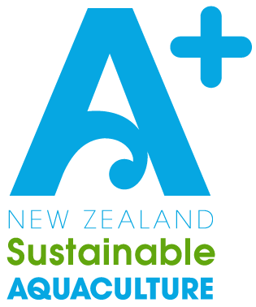

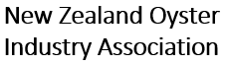

Biosecurity

Management Plan Template

Pacific Oysters

Company Name: [Insert company name here]

Consent Numbers: [Insert consent numbers covered by this BMP here]

Message from AQNZ
This A+ Biosecurity Management Plan template is designed to be adapted to your particular marine farms and operations. Key sections for your input are marked with [red].
Please delete any template instructions or irrelevant sections on your final version.
If you receive any feedback or required changes from your consenting authority in response to this management plan, please pass this on to AQNZ so we can continually improve our template.

Farm Manager or Other Staff Responsible for Biosecurity:
Name: | Phone / Contact Info:
[Insert Biosecurity Staff details here]

Prepared by: Dr David Taylor (AQNZ), Robin Britton (Resource Management Consultant), Steph Hopkins (AQNZ), Tom Hollings (NZOIA), Caroline Gilbertson (AQNZ)
This document should be reviewed annually to ensure it remains up to date against biosecurity legislation and best practice in New Zealand Aquaculture.
Date Last Amended / Reviewed | Person(s) Involved | Description of Changes / Review
20/02/2024 | Dave Taylor, Caroline Gilbertson | Review & Update to align with 2023 oyster biosecurity standard review & recent CAN changes.

Table of Contents
1. Purpose 4
2. Glossary 6
3. Background 7
3.1 Biosecurity Contacts 7
3.2 Roles 8
3.3 National Operational Zones 8
3.4 Biosecurity Management Areas 9
4. Relevant Operational Zones and Management Areas 10
4.1 The Top of the North 10
4.2 The Top of the South 12
5. A+ Sustainable Management Framework 14
6. Knowing the Risk 14
6.1 Biosecurity Risk Species by Location 14
6.2 Further Information on Notifiable Organisms 16
6.3 Pathways 16
7. Managing Biosecurity Risk – Best Practice Outline 17
7.1 People & PPE 17
7.2 Inspections 18
7.3 Stock 18
7.4 Equipment 21
7.5 Vessels & Vehicles 22
7.6 Waste / Disposal 23
8. Reporting Procedures for New Disease / Species Detected 24
9. Training 24
10. Recording, Reporting, and Review 26
11. APPENDIX 1: Potential Pest Pathway Assessment 27
12. APPENDIX 2: Operational Procedures and Recording 29
13. APPENDIX 3: Report Form for New Marine Pests and / or Diseases 31
14. APPENDIX 4: Biosecurity Event Contingency Plan 32
15. APPENDIX 5: Sampling Kit & Process 34

Purpose
The A+ Pacific Oyster Biosecurity Standards (https://www.aquaculture.org.nz/resources/general) guide the development of Biosecurity Management Plans (BMP), and provide a national approach to marine biosecurity, identify high risk pathways, and potential controls for those risks.
The purpose of this BMP is to comply with the A+ Biosecurity Standards and in doing so minimise the risk to our growing environment and our businesses from introducing, exacerbating, and spreading disease, unwanted marine organisms, or pest species.
This BMP also addresses the requirements of the National Environmental Standard for Marine Aquaculture (NES-MA), the Biosecurity Act 1993, the Fisheries Act 1996, and any consent requirements under the Resource Management Act 1991 (RMA).
The A+ Pacific Oyster Biosecurity Standards are reviewed every two years (next review due Oct 2025) and to ensure ongoing alignment with these regulations and global best practice.

For the farm sites covered by this plan, the resource consent condition(s) relating to biosecurity management is / are:
[List relevant consent conditions here]
- A
- B
- C

EXAMPLE CONSENT CONDITIONS
WRC Consent:
A biosecurity management plan shall be prepared by a suitably qualified and experienced person. The purpose of the biosecurity management plan is to minimise the risk of introducing, exacerbating, and spreading disease, unwanted marine organisms or pest species. The plan shall include the following information:
(i) Description of the biosecurity and disease risks related to the marine farm;
(ii) Details of diseases, marine pests, unwanted and notifiable organisms and marine fouling organisms identified by the Ministry for Primary Industries, Council and the marine farming industry for the area of operation including transport pathways;
(iii) Details of best practice farm management (including stock, equipment and vessels) to minimise the risk of introducing, exacerbating and spreading diseases and species of concern;
(iv) Procedures (including disposal protocol) if any new disease or new or unwanted organisms or species of concern have been detected;
(v) Details of training for operational staff on biosecurity and disease management, requirements and responsibilities;
(vi) Programme for monitoring for diseases and marine pests including identification, record keeping and reporting procedures.
The plan, and any updates to the plan, shall be submitted to the Council for written approval in a technical certification capacity. The basis of the approval will be limited to a technical assessment as to whether or not the plan, and any updates to the plan, have been developed in sufficient detail so as to meet the plan’s purpose.
The consent holder shall submit the plan to Council for Variation of this consent. An updated plan shall be submitted by the consent holder for review no later than 30 September 2026 and at five yearly intervals thereafter, and the plan shall be updated within two months of the identification of a new pest or unwanted pest species in the region, to achieve the purpose of the plan and ensure best practice management. The approved plan and any subsequent approved updates shall be implemented by the consent holder.
Any information recorded in accordance with the requirements in the biosecurity management plan shall be made available to Council on request and within two weeks of the request.

Glossary
Biosecurity Coordinator (Company) | Designated by a company in their Biosecurity Management Plan as the contact point for biosecurity issues, queries, or in-house management. This individual is responsible for liaising with the operational zone biosecurity coordinator as per these standards. A company does not have to have an in-house Biosecurity Coordinator.
Biosecurity Coordinator (Operational Zone) | Designated person within an Operational Zone as the central industry contact point for wider biosecurity communications. They should be informed by companies of any potential biosecurity events
Biosecurity Management Plan (BMP) | Each company is required to have their own BMP which meets the requirements set out by these standards. BMP Templates and resources can be found at: http://www.aplusaquaculture.nz/biosecurity
Biosecurity Standards | This document defines the industry agreed minimum biosecurity requirements and expectations for the purpose of minimising and mitigating biosecurity risk to and from the aquaculture industry in New Zealand. All company Biosecurity Management Plans should meet the requirements of these standards.
Controlled Area Notice (CAN) | Under the Biosecurity Act 1993 government agencies and regional councils can declare additional biosecurity controls and restrictions for specific areas in response to heightened risk or biosecurity incursions. All individuals operating within a CAN are legally required to comply with the measures detailed in the notice.
Decontamination | Decontamination is the cleaning, treating, and drying of equipment to a degree that ensures the inactivation of pest and pathogens. Decontamination methods may vary depending on equipment and the Decontamination Standards listed in this document should be followed.
Disease | A disorder / sickness in animals and plants
Facility | Includes on-water and land-based sites and structures, such as: Processing plants, yards, farm sites, hatcheries, etc.
Fomite | A thing or individual that could spread disease between locations. Could include personnel, equipment, animals, stock, etc
Fouling | Unwanted plants and animals that grow on vessels and equipment, particularly vessel hulls and farm structures.
Government Industry Agreement (GIA) | The Government Industry Agreement for Biosecurity Readiness and Response. GIA operates as a partnership between primary industry and government to manage pests and diseases that could badly damage New Zealand's primary industries, economy, and environment. https://www.gia.org.nz/
High Risk Areas | Areas of high risk are often included within management areas by councils. These are often places with lots of vessel traffic, such as busy harbours. You can identify areas of high risk within your own operations and adjust your BMP to mitigate the risk when operating in these areas.
Incursion | The arrival or establishment of a pest or disease species in an area where it previously had not been found.
Biosecurity Management Area | Management areas are localised areas within an Operational Zone with specific management requirements or measures. These can include any regional CAN, or industry agreed sites of heightened risk. Management areas are changeable based on current information and circumstance and consequently are not listed in these standards. It is expected that companies will detail all management areas relevant to their practices within their BMP and keep these up to date.
Moribund | Dead or dying stock
MPI Surveillance and Incursion Investigation Group | These are the individuals responding to the MPI biosecurity hotline and are responsible for making response decisions to any reported potential biosecurity event. They will assess the information provided by the farmer and decide if any sampling / testing or operational response is required. All response actions in a Biosecurity event will be dictated by this team. Not all calls to the hotline will result in any required action.
Notifiable pest / disease | Pests and diseases that must be reported to MPI, if spotted in New Zealand. https://www.legislation.govt.nz/regulation/public/2016/0073/latest/whole.html#DLM6792208
Operational Zone (OZ) | These are the large regional biosecurity control areas defined by these Biosecurity Standards. These areas are based on factors such as interconnectedness, regional management bodies, areas of operation, and environmental variations. Farming operations may in many cases span across multiple OZ’s and will therefore require additional biosecurity control measures as dictated by these Standards.  For details see Figure 1 section 3.3.
Pathogen | An organism causing disease in a host species.
Pathways | Pathways are the ways that pests and unwanted organisms are spread between areas. Pathways can include vessels, equipment, people, animals, and stock itself.
Pest / Invasive species | An organism that could cause harm to natural environments and industry operations. https://www.mpi.govt.nz/biosecurity/how-to-find-report-and-prevent-pests-and-diseases/search-for-a-pest-or-disease/
Potential Biosecurity Issue | This is when unusual or ramping mortality is observed, or a suspected unwanted organism that is new to the Operational Zone is observed. Potential Biosecurity Issues must be reported to a Biosecurity Coordinator, or directly to the MPI Pest and Disease Hotline.
Potential Biosecurity Event | This is when MPI or Regional Council have determined that a biosecurity incursion of some kind may be occurring, and they have recommended actions that could affect wider industry. The Operational Zone Biosecurity Coordinator must be involved if a Potential Biosecurity Event is enacted.
PPE - Personal Protective Equipment | The safety clothing and gear required in situations where risks are present and can be mitigated (e.g., handling of chemicals, operation of machinery, water safety, handling of disease or sickness, etc.)
Risk Pathways | Describes methods by which pests or disease could be spread from place to place. Pathways can be both national and international and can vary in type depending on the traits of the risk organism. Pathways can include things such as commercial vessels, recreational vessels, farm visitors and other personnel, stock movements, vehicles, water, wild animals, equipment, etc.
Unexplained Mortality | Any farm mortality that occurs outside of agreed normal limits or without apparent reason. Explained mortalities could include die-off in response to weather events, etc. Unexplained mortality cannot be associated with any sufficient explanation. If unsure whether something is explained or unexplained, call the MPI hotline and they will provide guidance.
Unwanted Organism | Pests and diseases that could harm New Zealand if they arrived. https://pierpestregister.mpi.govt.nz/
Waste Products | Waste products can be organic or inorganic materials generated by farming. These can include used equipment, dead (non-diseased) stock, shells, water used in processing or cleaning, ropes and floats, etc. Their history of use may pose a biosecurity risk and could require management.
Add any additional definitions relevant to your operations.

Background
Marine farmers recognise they have a role in the management of biosecurity risks. Biosecurity management is an essential part of the day-to-day operations on a marine farm. This Company will always strive in all respects to minimise the biosecurity risk arising from introductions and/or spread of unwanted pests and notifiable organisms (including pests and pathogens) arising from the Company’s farming operations.
However, it is also recognised that the control of biosecurity risks is a shared responsibility between the marine farmer, other commercial operators, recreational boat owners, other marine farmers, local authorities (Councils) and Government (Ministry for Primary Industries - Biosecurity New Zealand).

It is the policy of this Company that all operational farm staff must comply
with this Biosecurity Management Plan.

3.1 Biosecurity Contacts
Below are some of the key contacts relating to aquaculture biosecurity management throughout NZ. Make sure these are up to date and that all appropriate contacts for your farm areas are included whenever reviewing your BMP. If you have designated a Company Biosecurity Coordinator please add their details below.
Contact | Name | Details
MPI / Biosecurity NZ Pest and Disease Hotline | Marine Incursion Investigator | 0800 80 99 66
Top of the North Operational Zone – North Biosecurity Co-ordinator | Roly Rush | 027 700 1077
Top of the North Operational Zone – South Biosecurity Co-ordinator | Dave Taylor | 021 677 119
Top of the North Biosecurity Partnership | Bay of Plenty Regional Council | https://www.marinepests.nz/
Top of the South Biosecurity Co-ordinator | Ned Wells | 03 578 5044
Top of the South Marine Biosecurity Partnership | Peter Lawless | 021 894 363
NZOIA Secretary | Tom Hollings | 027 495 3957
Aquaculture NZ Technical Director (Biosecurity) | Dave Taylor | 021 677 119
MPI online Tool for reporting suspected pests |  | https://report.mpi.govt.nz/pest/
Marine Pest ID website |  | marinepests.nz/marine-pest-id
Northland Regional Council: |  | 0800 504 639
Auckland Council: |  | pestfree@aucklandcouncil.govt.nz  09 301 0101
Waikato Regional Council |  | 0800 800 401
Bay of Plenty Regional Council |  | 0800 786 773

3.2 Roles
In terms of this Biosecurity Management Plan, the following have key roles:
- Ministry for Primary Industries (MPI): The Biosecurity Act 1993 and the Fisheries Act 1996 are implemented by Fisheries NZ. The Fisheries Act includes rules around fish farm licences. The Biosecurity Act requires that any suspected unwanted organisms, and all significant diseases and abnormal/high mortality rates to be reported to the MPI Hotline 0800 80 99 66.

- Regional Councils: Councils are responsible for the implementation of the Biosecurity Act 1993 (through pest management plans) and the Resource Management Act 1991 (through resource consents and plans).

- Aquaculture New Zealand (AQNZ): AQNZ has a national role that acknowledges the importance of reducing risks and keeping industry players informed. In this context the A+ Sustainable Management Framework is a key method for delivery.

AQNZ under the A+ Sustainability Framework has prepared additional information on biosecurity management and marine farmers have access to this information and to advice on improving procedures over time to manage biosecurity risk:
https://www.aplusaquaculture.nz/biosecurity

3.3 National Operational Zones
Operational Zones (Figure 1) were formed by the aquaculture industry to ensure a national approach to marine biosecurity risk under the A+ New Zealand Pacific Oyster Biosecurity Standards. Operational Zones where marine farming occurs include: Top of the North, Top of the South Island, Canterbury, and Lower South. Operational Zones are generally aligned with Biosecurity partnership areas identified by regional councils. The Top of the North Operational Zone includes Northland Regional Council, Auckland Council, Waikato Regional Councill and Bay of Plenty Regional Council. The Top of the South Operational Zone includes Tasman District Council, Nelson City Council, Marlborough District Council, Taranaki Regional Council and Greater Wellington Regional Council.
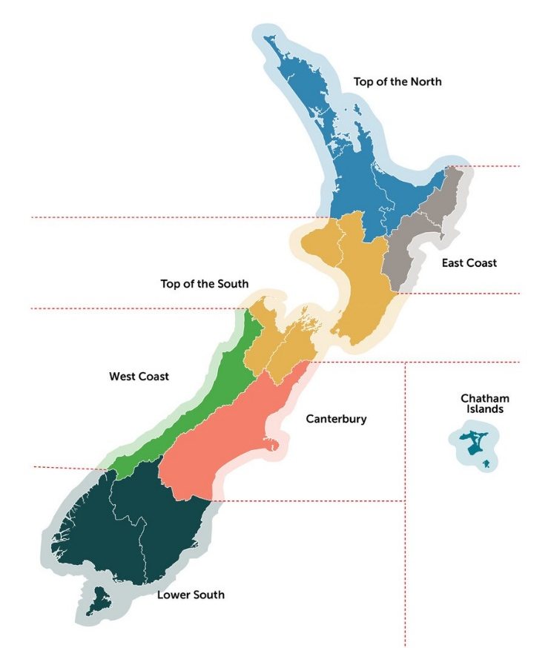
Figure 1: NZ Aquaculture Industry Operational Zones

3.4 Biosecurity Management Areas
Within each Operational Zone, Biosecurity Management Areas are identified to distinguish those areas that warrant or require additional biosecurity measures.
Management Areas are identified based on the following criteria:
- Regional and national statutory biosecurity requirements (e.g., Regional Pest Management Plans, Small-Scale Management Plans, Controlled Area Notices which may include policies, controls and rules related to the management and control of marine biosecurity risks associated with aquaculture pathways).
- Agreement within or between companies (e.g., a Management Area Agreement), where multiple growers farm in a shared waterbody and / or share facilities (e.g. within an area managed by a Delivery Centre)
- High risk pest area (e.g. port, harbour, or marina) that has a lower biosecurity status than nearby farms (e.g. Port of Auckland, and Coromandel Harbour all have unmanaged populations of Sabella).

Relevant Operational Zones and Management Areas
This section contains details about the different Management Areas specified for each operational zone. Delete all sections that are not relevant to your specific farming operations. Any zone that you move stock or farming equipment into or out of should be included in this BMP. Staff training should include understanding the details outlined in this section.

4.1 The Top of the North
The TNOZ boundaries are from the northern Taranaki clockwise around the coast to East Cape. The main Oyster growing areas within the TNOZ are Coromandel, Auckland, and Northland.

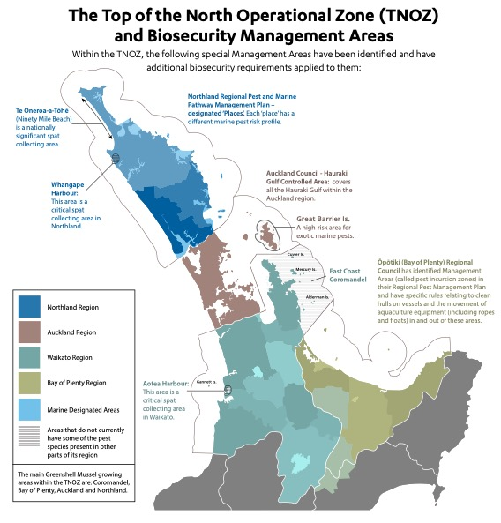
Figure 2: TNOZ Management areas

For oyster farms within the TNOZ, the following Management Areas have been identified and have additional biosecurity requirements applied to them:
Northland Region
- Northland Regional Council has identified Management Areas (called marine designated ‘places’) in their Regional Pest Management Plan (RPMP). Each ‘place’ has different marine pest profile so additional pathway measures must be applied for movements between these ‘places’, as some are significant oyster farming areas (e.g., Whangaroa Harbour and Bay of Islands).
- A Management Area is in place for Te Rāwhiti inlet as there is a Controlled Area Notice in force. The Te Rāwhiti Caulerpa Controlled Area Notice 2023 establishes movement controls and specify treatments and procedures to enable the limitation of the spread of Caulerpa brachypus and Caulerpa parvifolia (exotic Caulerpa species).
- Additional industry agreed Management Areas with specific control measures include:
  - Parengarenga Harbour: This is a receiving area for oysters from another Operational Zone.
  - Hokianga Harbour: does not currently have some of the pest species present in other parts of the Northland region.
  - All of Kaipara Harbour (includes part of Auckland region): This is a significant oyster farming area on the west coast and does not currently have some of the pest species present in other parts of the Northland region.

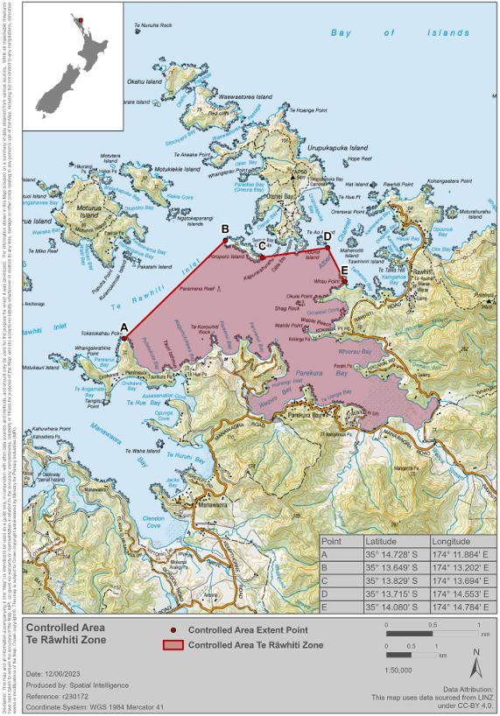
Figure 3: Te Rāwhiti Caulerpa Controlled Area Notice 2023

Auckland Region
- Great Barrier Island (Aotea) is a high-risk area for exotic marine pest incursions. Management Areas are in place as there is a Controlled Area Notice in force for parts of Aotea - Great Barrier Island and Ahuahu - Greater Mercury Island to control the spread of two Caulerpa sp.
- Auckland Council - Hauraki Gulf Controlled Area Notice: covers all the Hauraki Gulf within the Auckland region and has restrictions and associated fines around the movement of known marine pest species.

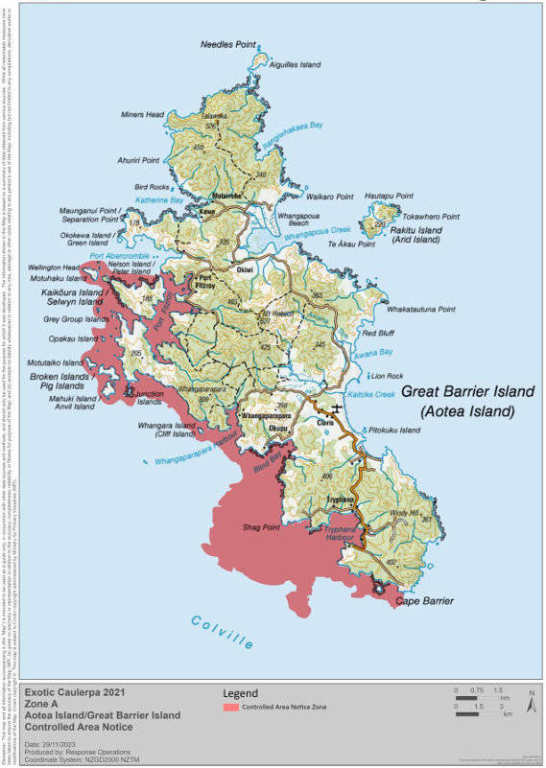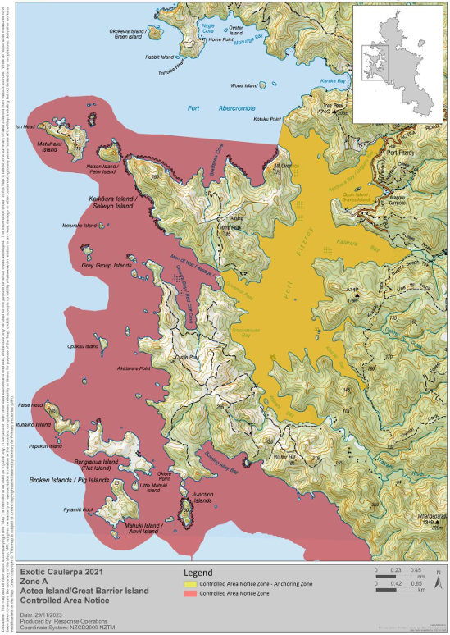
Figure 4: Great Barrier Island Controlled Area Notice

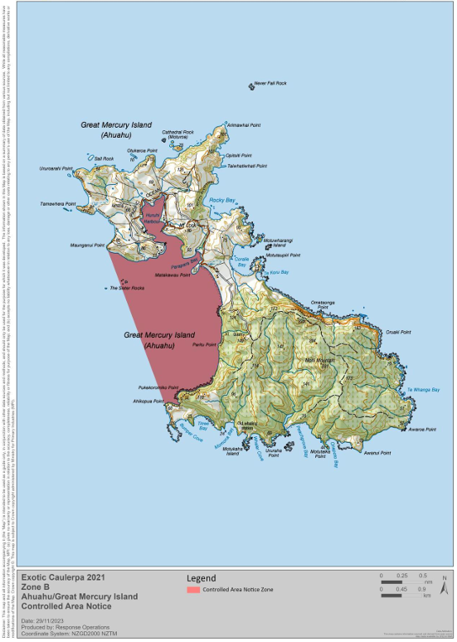
Figure 5: Great Mercury Island Controlled Area Notice

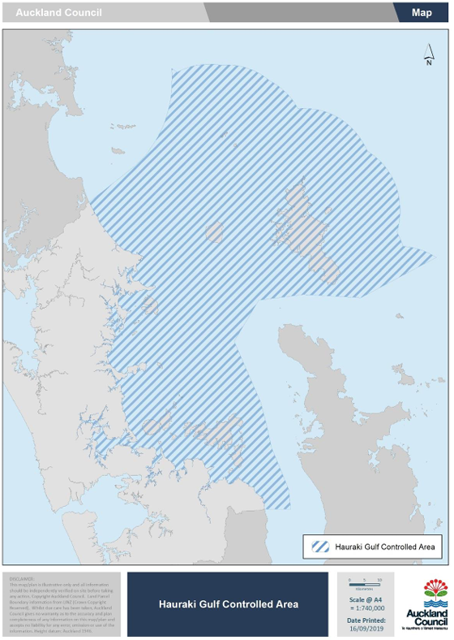
Figure 5: Hauraki Gulf Controlled Area Notice

Waikato Region:
Agreed industry Management Areas with specific control measures include:
- The East Coast Coromandel: This area does not currently have some of the pest species present in other parts of the Waikato region.
- Kawhia & Aotea Harbours do not currently have some of the pest species present in other parts of the Waikato region.
Bay of Plenty Region
- Ōpōtiki (Bay of Plenty): Bay of Plenty Regional Council has identified Management Areas (called pest incursion zones) in their Regional Pest Management Plan and have specific rules relating to clean hulls on vessels and the movement of aquaculture equipment in and out of these areas.

4.2 The Top of the South
The Top of the South Operational Zone (TSOZ) boundaries are from the NW boundary of Southland to Northern of Taranaki regional boundary over to the NE Manawatu – Wanganui regional boundary and down to the SE Marlborough boundary at Clarence). The main oyster growing area within the TSOZ is the Marlborough Sounds.

TSOZ Management Areas:
Within the TSOZ, the following Management Areas have been identified and have additional biosecurity requirements applied to them:
Nelson / Tasman Region:
Bonamia CAN in place – a movement permit must be attained from MPI- BNZ for any shellfish not going to processing for human consumption out of the ‘Upper South Contained Zone’ (Figure 6).
For more details see: https://www.mpi.govt.nz/biosecurity/long-term-biosecurity-management-programmes/bonamia-ostreae-parasite-control-in-oysters/
- Wainui: This area is a critical spat collecting area and does not currently have some of the pest species present in other parts of the Operational Zone.
- Tarakohe harbour: This harbour has pest species under ongoing management that are not present in other parts of TSOZ (e.g., Sabella).
- Port Nelson and Nelson Marina: This harbour and marina has pest species under ongoing management that are not present in other parts of TSOZ.
Marlborough:
Bonamia CAN in place – a movement permit must be attained from MPI- BNZ for any shellfish not going to processing for human consumption out of the ‘Upper South Contained Zone’.
For more details see: https://www.mpi.govt.nz/biosecurity/long-term-biosecurity-management-programmes/bonamia-ostreae-parasite-control-in-oysters/
- Pelorus Sound - Admiralty Bay: is considered a higher-risk area for exotic marine pests as it has a large vessel anchoring site (this area is a candidate for additional surveillance)
- Queen Charlotte Sound - Waikawa Marina: This marina has pest species under ongoing management that are not present in other parts of TSOZ (e.g. Sabella).
Wellington:
- Wellington harbour: This harbour has pest species under ongoing management that are not present in other parts of TSOZ.

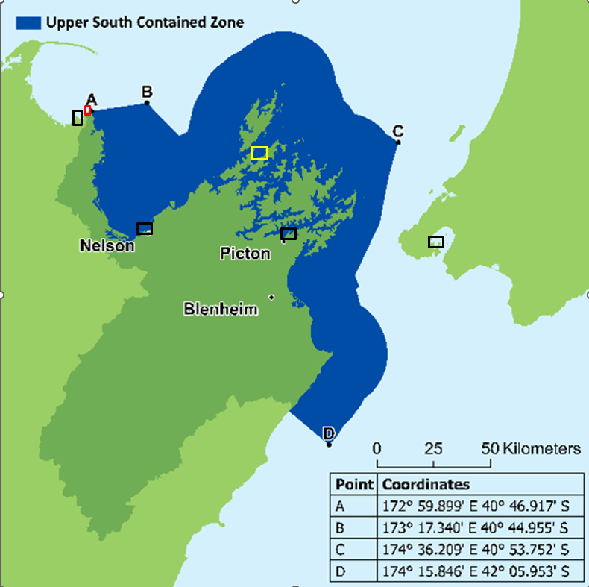
Figure 6: TSOZ Management Areas: Dark Blue - Bonamia CAN ‘Upper South Contained Zone’, Black – high risk harbours and marinas, Red – Wainui Bay Mussel Industry Management Area, Yellow – large vessel anchoring – additional surveillance.

A+ Sustainable Management Framework
Aquaculture farmers are encouraged to participate in the Aquaculture New Zealand’s A+ Environment Programme. A+ is an improvement programme that provides New Zealand aquaculture farmers with the practical tools to demonstrate transparency around their environmental performance with annual checklists that are completed by the producer.
The objectives of A+ align with those of world leading accredited certification programmes such as Aquaculture Stewardship Council (ASC) and Best Aquaculture Practice (BAP). This association further substantiates the importance we place on our role as responsible guardians of our place and people.
The A+ Sustainable Management Framework (SMF) formalises a cycle of annual reporting and review for continuous improvement and provides a great platform for the community and industry to engage on their sustainability aspirations.
The purpose of the SMF is to promote the sustainable management of aquaculture in New Zealand by providing guidance for best environmental and social practice for the industry. More information can be found on the A+ website - http://www.aplusaquaculture.nz/

Biosecurity in A+
Biosecurity is a key component of the A+ Sustainable Management Framework. AQNZ, through an industry working group process, has developed the A+ Pacific Oyster Biosecurity Standards and this Biosecurity Management Plan is designed to comply with these industry standards. The standards can be found at http://www.aplusaquaculture.nz/biosecurity

Knowing the Risk

6.1 Biosecurity Risk Species by Location
Notifiable pests and diseases under the Biosecurity Act that are present in NZ by Operational Zone. You must notify MPI if these pests are observed in new locations.

Names | Site, Species or Region Detected | Additional Information
Top of the North
Mediterranean fan worm  (Sabella spallanzanii) | Auckland and Waikato | Hauraki Gulf Controlled Area Notice 2020 in place to reduce risk of spread to outer islands (e.g., Great Barrier Island): https://www.aucklandcouncil.govt.nz/environment/what-you-can-do-for-environment/Documents/hauraki-gulf-can-2020.pdf  Also trying to reduce risk of spread to industry Management Areas on West Coast North Island (e.g., Aotea Harbour) and Eastern Coromandel.
Perkinsus olseni  (shellfish parasite) | Confirmed in paua, mussels, scallops, oysters, and other shellfish
Caulerpa species  Caulerpa brachypus and Caulerpa parvifolia | Great Barrier Island (Tryphena Bay, Blind Bay, Whangaparapara Bay), Great Mercury Island (Western Bays), Te Rāwhiti Inlet (Bay of Islands) | Controlled Area Notice in place: https://www.mpi.govt.nz/dmsdocument/47557-Exotic-Caulerpa-Aotea-and-Ahuahu-Controlled-Area-Notice  https://www.mpi.govt.nz/dmsdocument/57259-Te-Rawhiti-Exotic-Caulerpa-Controlled-Area-Notice-2023
Top of the South
Bonamia ostreae (oyster parasite) | Tasman, Nelson, Marlborough | Controlled Area Notice in place – stock movement permits required: https://www.mpi.govt.nz/dmsdocument/44620-Bonamia-controlled-area-notice
Mediterranean fan worm  (Sabella spallanzanii) | Port Tarakohe (Tasman), Port Nelson (Nelson), Waikawa Marina (Marlborough) | Small-Scale Management Programme in place for Top of the South: (e.g. https://www.nelson.govt.nz/assets/Environment/Downloads/Water/sabella/NCC-Small-Scale-Management-Programme-for-Sabella-2017.pdf)
Perkinsus olseni  (shellfish parasite) | Confirmed in mussels and other shellfish
Canterbury
Mediterranean fan worm  (Sabella spallanzanii) | Lyttleton Port | Industry Management Area control in place to reduce risk of spread to aquaculture facilities
Lower South
Bonamia ostreae (oyster parasite) | Southland (Big Glory Bay) | Controlled Area Notice in place: https://www.mpi.govt.nz/dmsdocument/44620-Bonamia-controlled-area-notice

Other marine pests that are known to occur some Operational Zones and Management Areas including several ‘unwanted organisms’. The biosecurity controls detailed in this document are also aimed at reducing the risk of exacerbating the spread of fouling organisms like:
- Clubbed tunicate (Styela clava)
- Australian droplet tunicate (Eudistoma elongatum)
- Wakame (Undaria pinnatifida)
- Colonial Sea Squirt (Didemnum vexillum)

6.2 Further Information on Notifiable Organisms
Further information on unwanted pests and notifiable organisms under New Zealand legislation:
The National Biosecurity (Notifiable Organisms) Order 2016 can be found in this link: https://www.legislation.govt.nz/regulation/public/2016/0073/9.0/whole.html
Additional MPI information regarding unwanted pests and notifiable organisms can be found in this link: https://www.mpi.govt.nz/biosecurity/how-to-find-report-and-prevent-pests-and-diseases/registers-and-lists/
Booklet published by MPI: New Zealand Marine Pest ID guide or any updates to this publication, link: https://www.mpi.govt.nz/dmsdocument/10478-new-zealand-marine-pest-id-guide
Top of the South Marine Biosecurity Partnership Incident Response Manual: https://www.marinebiosecurity.co.nz/manuals-plans

6.3 Pathways
Pathways are defined as routes of introduction and spread of unwanted organisms, including pathogens and pests, into the farm. Managing pathways minimises the likelihood of introducing or spreading unwanted organisms.
Biosecurity risk management practices are designed to control possible pathways for the introduction and spread of pathogens and pests.
- Early detection is key in pest and pathogen management – the best time to control any marine pest or pathogen is on arrival.
- Marine farms can provide habitats for the settlement, growth and spread of marine pests and pathogens. As well as having a direct impact on the farming operation, marine pests and pathogens can be introduced and spread to other farms and the wider aquatic environment.
- Once a pest or pathogen is established, control becomes more difficult and expensive.
- Therefore, knowing the higher risk pathways (e.g. moving equipment between Management areas or Operational Zones) for the introduction and spread of pests and pathogens is extremely relevant.
- Higher Risk Pathways are identified in Appendix 1.

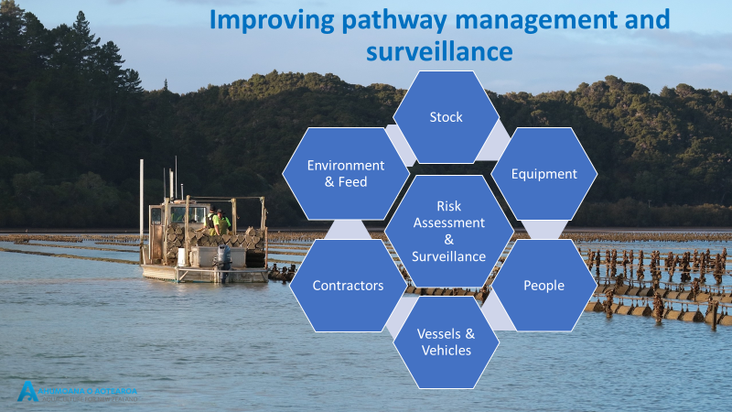

Managing Biosecurity Risk – Best Practice Outline
This section sets out controls that will be used to manage biosecurity risks associated with general oyster farm operations. This section should be updated to reflect relevant farming practices when this BMP is implemented or reviewed.
If staff observe a new pest or unusual signs of disease or unexpected mortality >20% at any farm, the disease or mortality event must be investigated to determine causation.
Farm staff must contact the regional Biosecurity Coordinator or AQNZ, who will:
- contact the MPI Hotline 0800 80 99 66 and
- if necessary, coordinate sampling and
- Notify all relevant farming groups, NZOIA, biosecurity groups, and local farmers
For new pests see Appendix 3.
The Contingency Plan in Appendix 4 must be activated.

7.1 People & PPE
People and their PPE (e.g., gumboots, overalls) can transfer pests and diseases onto the farm. The biosecurity risks associated with people and their PPE will be controlled by:
Farm Staff | - Staff entering a farm will not wear protective clothing (PPE) worn in another Operational Zone without either laundering them or, in the case of PPE, it will be washed down, and disinfectant solution will be applied.  - Protective clothing (PPE) will be worn by farm staff.  - Staff will wash down their PPE before entering another farm or Management Area.
Visitors and Contractors | - Visitors and contractors will receive a briefing regarding the biosecurity requirements under this plan prior to entering facilities and farm sites.  - A record of visitors and contractors will be kept, including:  - Name and contact details  - Confirmation that they are aware of and will comply with the requirements of this BMP  - A record of whether they have visited a high-risk aquaculture facility in the last 72 hours (e.g., hatchery, processing facility, wild habitat where the farmed species exist).  - All visitor and contractor PPE used or worn outside the Operational Zone or that is considered high risk, will be washed down (ideally with fresh water), and disinfectant solution will be applied.

7.2 Inspections
It is important to remain vigilant for new/ unwanted marine species:
- All staff will keep a look out for any new/ unwanted marine species when undertaking any work on the farm or cleaning any equipment or vessels.
- Every vessel will have a copy of the “MPI Biosecurity NZ Marine Pest ID Guide” on board at all times and all farm staff will be trained in identifying unwanted pests.

7.3 Stock
It is important to remain vigilant for visual signs of disease (e.g., unusual lesions) and elevated mortality in farmed stock as early detection is the best hope for successful management.
Stock Health  (i.e., spat, seed, adults) | It is important to remain vigilant for visual signs of disease (e.g., unusual lesions) and elevated mortality in farmed stock as early detection is the best hope for successful management:  - A sample of stock will be visually assessed for general health status (e.g., gaping and presence of visible lesions) every 3 months (quarterly) and prior to harvest.  - No spat or seed that are visibly unhealthy will be put out onto farms.  - Visibly unhealthy stock will not be moved from the farm until the cause of disease has been identified.  - Refer Appendices 2 & 3 for actions/ records to be kept.
Stock Transfers | This section should be edited to reflect the requirements of the farm areas covered by this specific BMP. As part of your implementation of this template, ensure that all stock transfer requirements for your areas of operation are included here. All staff & contractors involved in stock transfer should have a clear understanding of the requirements outlined here.  Stock transfers are a known pathway for the transfer of pests and diseases. The biosecurity risks associated with stock transfers will be controlled by:  General Rules for Stock Transfer  - Traceability records will be kept in accordance with Appendix 2  - Spat, seed or adult stock that are visibly unhealthy will not be transferred to or from any farm or facility.  - If there is a biotoxin harvest closure notice applied to an area, stock will not be moved outside this area, unless written agreement has otherwise been approved by the Biosecurity Co-ordinator.  - Stress on spat, seed or stock will be minimised by keeping them cool and moist during transport.  - Spat, seed or stock will not be transferred from any other Management Area or Operational Zone that is known to contain a notifiable disease or pest, and which is not already present in the destination Management Area or Operational Zone, unless a movement permit has been provided by MPI (e.g., Bonamia Controlled Area Notice – movement permit).  - Any stock to be transferred between Operational Zones will be de-clumped, cleaned of obvious fouling, and visually checked for signs of disease/ notifiable organisms prior to transporting.  - No seawater will be sprayed onto stock when they are moving through ports / harbours/ or marinas known to contain notifiable organisms (e.g., Sabella).  Stock movement between Management Areas  If moving stock between Management Areas or Operational Zones, the farmer will check the biosecurity status and meet the stock movement requirements of those Zones/ Management Areas prior to any transfer of stock.  Some transfer requirements for specific regions have been included below. As part of your preparation/review of this document, you should make sure that all specific transfer requirements relevant to your farming practices are specified.  TNOZ Management Areas  Parengarenga, Hokianga, Kaipara and Kawhia Harbours  - Any stock to be transferred will be visually checked for signs of disease/ unwanted organisms prior to being transported.  - Spat will not be moved from the Management Areas to other areas when there is a marine biotoxin harvest closure notice applied to the harbour, unless the TNOZ Biosecurity Co-ordinator provides written notice otherwise.  - Any transfer of stock will be undertaken in accordance with the statutory requirements of the relevant regional councils, and in accordance with the Biosecurity Act 1993 (e.g. Hauraki Controlled Area Notice 2020, Aotea and Ahuahu, and Te Rāwhiti Caulerpa Controlled Area notices, , Bay of Plenty Regional Pest Management Plan).  East Coast Coromandel  - Only spat from the following areas will be transferred to the East Coast of the Coromandel:  - Management Areas that are free from Sabella spallanzanii and Undaria pinnatifida and free from other listed marine pests not currently present in the East Coast Coromandel Management Area.  - Spat will not be moved from East Coast Coromandel to other areas when there is a marine biotoxin harvest closure notice applied to the East Coast Coromandel, unless the TNOZ Biosecurity Co-ordinator provides written notice otherwise.  Other Management Areas within TNOZ  - Any transfer of stock to or from Management Areas in Northland, Auckland or the Bay of Plenty council regions will be undertaken in accordance with the statutory requirements of these councils, and in accordance with the Biosecurity Act.  - Caution will be taken when moving stock from areas where Caulerpa Controlled Area Notices are in place to ensure any obvious seaweed fouling is removed and disposed of safely on land.  Management Areas outside of TNOZ (including Top of the South, Canterbury, Lower South)  - Spat, seed or stock to be transferred from any other Management Area or Operational Zone (outside of TNOZ) that is known to contain a notifiable pathogen or pest and which is not already present in the destination Management Area or Operational Zone, must undergo a risk assessment by a suitably qualified biosecurity expert prior to movement. Movements will only proceed once the recommended risk mitigations identified in the risk assessment can be complied with.  - Stock will not be moved from any other Management Area or Operational Zone where toxic algal cells are present at concentrations at which flesh testing is required unless a risk assessment has been undertaken by a suitably qualified aquatic health professional and appropriate risk mitigation is in place.  - Any stock to be transferred to or from any other Management Area or Operational Zone (outside of TNOZ) will be cleaned of obvious fouling, and visually checked for signs of disease/ unwanted organisms at origin, prior to transporting.  - Any transfer of stock to or from Management Areas in the TSOZ will be undertaken in accordance with the statutory requirements of the relevant regional councils, and in accordance with the Biosecurity Act 1993 (e.g. a movement permit must be applied for if moving stock out of the ‘Upper South Contained Zone’ under the Bonamia – Controlled Area Notice)  - Bonamia Controlled Area Notice – a movement permit must be attained from MPI- BNZ for any shellfish not going to processing for human consumption out of the ‘Top of the South Contained Zone’. For more details see: https://www.mpi.govt.nz/biosecurity/long-term-biosecurity-management-programmes/bonamia-ostreae-parasite-control-in-oysters/  - Stock to be moved from Admiralty Bay will undergo additional checks for unwanted or new to New Zealand organisms prior to movement.  - Seawater will not be sprayed onto bags or baskets of stock when they are moving through ports / harbours/ or marinas known to contain unwanted organisms (e.g., Sabella).  NB: if moving stock between Management Areas or Operational Zones the farmer will check the biosecurity status and meet the stock movement requirements of those Zones/ Management Areas prior to any transfer of stock.

7.4 Equipment
Sample Kit | - The Farm Manager will have a sample kit to collect any new species detected or potentially diseased stock for testing (Refer Appendix 5).
Marine Equipment:  All Areas | To control the risks associated with:  Sticks, Bags, and Baskets:  - Attached fouling will be removed from baskets, bags or sticks at time of harvest, as much as practicable and discharged within the marine farm boundary.  - All baskets, bags or sticks will be further cleaned of obvious fouling and dried when landed at yard.  - All waste from cleaning will be collected and disposed of to landfill.  - All baskets, bags or sticks will be stored and dried for a minimum of 2 weeks before re-using in any other Management Area (NB: refer below exceptions for Parengarenga, Hokianga, Kaipara, Kawhia Harbours and East Coast Coromandel).  Backbone Lines and Racks:  - Backbone lines and racks will be checked every 6 months for any notifiable organisms.
Marine Equipment:  Other Management Areas/ Operational Zones | - Baskets, bags, or sticks from outside the Management Area (excluding Parengarenga, Hokianga, Kaipara, Kawhia Harbours and East Coast Coromandel) or Operational Zone will not be re-used unless they have firstly been decontaminated, in accordance with the Special Decontamination Requirements detailed in the A+ Oyster Biosecurity Standards.  NB: if moving equipment between Management Areas or Operational Zones the farmer will check the biosecurity status and meet the requirements for those Zones/ Management Areas prior to any transfer of equipment.
Marine Equipment:  Additional Industry Management Areas | Parengarenga, Hokianga, Kaipara and Kawhia Harbours and East Coast Coromandel Management Areas  - Used farm equipment (e.g., baskets, bags, sticks) in Parengarenga, Hokianga, Kaipara, Kawhia Harbours or East Coast Coromandel Management areas must be:  - Used solely in each of these Management Areas; or  - Cleaned and dried for at least 12 weeks before being transferred into these Management Areas; or  - decontaminated in accordance with the A+ Biosecurity Standards.  Specify any exceptions or additional measures for specific Management Areas related to your farming operations here.

7.5 Vessels & Vehicles
Vessels | Vessel hulls and decks can carry marine pests and diseases. The risks associated with vessel movements will be controlled by:  - Biofouling on the hulls of farm vessels will be kept at no more than a slime layer and barnacles  - In-water cleaning should only occur where the vessel only works in one Management Area  - In-water cleaning will not occur if there is a risk of transferring an unwanted organism to the cleaning site.  - Niche areas will be checked every 12 months including: e.g., keel bottom, hull fittings, and thruster cavities)  - Bilge water and/or water in the strum box and associated pipework will be pumped out once the vessel has left the farm area and is in open water, if travelling:  - between different Management Areas; or  - between different Operational Zones.  - Trailered marine farming vessels and equipment will be washed with freshwater and all water drained from bilges, after removal from the sea.  - Contractor vessels will be required to show evidence that they comply with the above controls.  Vessels traveling between Operational Zones will comply with the Special Decontamination Requirements for aquaculture vessels detailed in the A+ Oyster Biosecurity Standards.  NB: In-water cleaning will not occur if a vessel has travelled between Operational Zones.
Harvesting / grading equipment etc | Harvesting/ grading equipment can transfer pests and diseases. The risks associated with the transfer of harvesting/ grading equipment will be controlled by:  - Sediment and biofouling debris will be cleaned from harvesting or grading equipment (with freshwater if in a land-based facility) between each harvest, or farm lot.  - Harvesting / grading equipment from outside the Management Area (excluding Parengarenga, Hokianga, Kaipara, Kawhia Harbours and East Coast Coromandel) or Operational Zone will not be re-used unless they have firstly been decontaminated, in accordance with the Special Decontamination Requirements detailed in the A+ Oyster Biosecurity Standards.
Vehicles | Vehicles that carry stock and equipment can transfer pests and diseases. The risks associated with the transfer of vehicles will be controlled by:  - Any vehicle/ trailer that has been used in other Management Areas or Operational Zones and which has potentially been in contact with aquatic pests, will be cleaned with freshwater and detergent between each transport event, and ideally before accessing wharf areas for reloading.

7.6 Waste / Disposal
Waste Management  (e.g., wastewater, solid waste, and biological waste/ dead/ moribund stock) | Waste can transfer pests and diseases. The risks associated with the transfer of waste will be controlled by:  - Referring to the Company’s Waste Management Plan  - Small quantities (less than 5 kg) of biological material that could pose a biosecurity risk will be disposed of in landfill.  - If more than 5 kg of dead or moribund stock will be disposed of, the stock will be contained in secure mort-bins with sealed covers or sealed bulk bags with plastic liners for transport to approved disposal facilities.  - Biological material (including dead or dying stock) will not be directed to bait or burley manufacture unless the Company knows that the requirement to inactivate any pathogens and pests can be achieved (e.g., sterilisation by heat treatment, chlorination, etc).  - Refer also to the Contingency Plan: Appendix 4

Reporting Procedures for New Disease / Species Detected
Standard operating procedures if a new disease or unwanted organism is detected:
If there is any doubt as to the status of an identified organism, staff can check in with the Biosecurity Coordinator or with MPI (0800 80 99 66 or https://report.mpi.govt.nz/pest/).

Training
It is important that staff know why biosecurity is important and understand their role in managing the risks to the environment and the business.
Staff biosecurity training will include:
- The Farm Manager (and/or other staff responsible for Biosecurity) will receive biosecurity training that will include:
  - A review of the A+ Pacific Oyster Biosecurity Standards and this biosecurity management plan.
  - A review of the biosecurity status of other industry Operational Zones.
  - The importance of maintaining stock records for traceability purposes during a biosecurity event.
  - Identification of normal healthy stock – appearance and behaviour.
  - Identification of unhealthy stock – signs of abnormal health and abnormal behaviours.
  - The appearance of unwanted marine pests, how to use the sample kit to sample unknown pest/diseased organisms, who to contact and where to send samples.
  - The importance of regular inspection and surveillance for marine pests and shellfish diseases to the industry, environment and for market access.
  - Environmental parameters to measure and record (DO, water temperature, phytoplankton), and why they are important if a shellfish health issue is suspected.
  - How biosecurity is regulated in New Zealand (Biosecurity Act 1993) and their role in the Government-Industry Agreement on Biosecurity (that the marine farming industry is a signatory to).
- Refresher training for general staff and discussion of operational matters – including the Biosecurity Management Plan – as per details in Appendix 2.

- All staff will be given within a month of starting and as an annual refresher course:
  - Basic biosecurity knowledge of AQNZ’s background documentation and expectations for Biosecurity Management, including industry changes over time.
  - Basic biosecurity training, including the appearance of, effects of, and reporting mechanisms for, legislated notifiable pests and signs of diseases
  - Knowledge of the contingency plan (i.e., steps to be taken in an extreme event or potential biosecurity event).

- All staff will:
  - Have access to an on-vessel copy of: NZ Marine Pest ID Guide and any additional Management Area and/or Operational Zone information (e.g. Controlled Area Notices); and
  - Have on-board practical training for signs of “unhealthy stock” (e.g., lesions / gaping), and
  - Know what to do if they observe specific unwanted pests or specific signs of disease.

Evidence of staff biosecurity training will be recorded in the Company’s training register and will be available on request.
Further Background Information:
A+ Pacific Oyster Biosecurity Standards:
https://www.aquaculture.org.nz/resources/general
http://www.aplusaquaculture.nz/sustainable-aquaculture

Aquaculture Biosecurity Handbook (MPI/AQNZ 2016):
https://www.agribusiness.school.nz/pluginfile.php/1994/mod_folder/content/0/2016-Aqua-Biosecurity-Handbook-On-farm-Risks.pdf?forcedownload=1

Recording, Reporting, and Review
The expectations around biosecurity data recording and reporting, and the reviewing of the BMP, are listed below. Make sure that all staff are aware of the recording and reporting requirements associated with their roles.
Additional reporting requirements may be required by your regional council. Please ensure that all required reporting is included in this BMP and remains true and up to date.
- The Farm Manager will review this Biosecurity Plan annually to ensure the most up-to-date management practices identified by AQNZ, government, or the regional environmental group are in place.

- Appendix 2 sets out the recording required for operational procedures.

- The information in Appendix 3 must be recorded when:
  - a potential new species is detected, or
  - when an unwanted organism (as per the MPI Pest ID handbook) is detected in a new area, or
  - when a potential disease event is observed.

- If a notifiable biosecurity event occurs, the Company will notify MPI and submit a report to MPI, within one week, covering all matters in Appendices 2 & 3. MPI are the lead agency.
The company will also inform:
  - The local Council Marine Biosecurity contact (see 2.1 Biosecurity Contacts and Appendix 4) and
  - AQNZ (info@aquaculture.org.nz)

APPENDIX 1: Potential Pest Pathway Assessment
NB: Procedures for managing these potential pathways are set out in sections 5 – 8 above.
Higher Risk Pathways for your Farm(s) (i.e., what are the potential ways pests/ disease will enter your farm through your operations)
Risk Pathway (Examples) | Think About | Answers specific to your farm operations and potential control measures
Vessels travelling between Management Areas | Do you commonly use your vessels between Management Areas?
Vessels traveling between Operational Zones | Do you commonly move your vessels between Operational Zones? | E.g.  Yes our vessels go between Marlborough and Banks Peninsula  Example potential control measures:  • Hull will be inspected before leaving  • Hull cleaning will be done where appropriate  • Deck will be washed and disinfected  • Vessel will be equipment washed and disinfected  • Bilge water will be exchanged at least once while in transit
Stock transfers (particularly between other Management Areas or Operational Zones) | Where do you commonly transfer stock to and from?  What is the pest and disease status of those sites?
Equipment transfers | Do you commonly move farm equipment between Management Areas or between Operational Zones?
People | Identify commonly used contractors. Do they move between Management areas or Operational Zones?
Any other pathways for pests/ diseases arising from farming operations? | e.g., exceptional use of another barge on your farm, or contractors with dive gear used in another Operational Zone?

APPENDIX 2: Operational Procedures and Recording
Records to be kept: the following can be tailored to mesh with your existing systems.
 | Standard Operations and Required Records
STOCK HEALTH
All Stock  (Quarterly & at harvest) | Date:  Farm Site:  Growth stage:  Health of Stock assessed:
Unhealthy Stock | Fill in Appendix 3  Check if Appendix 4 needs to be activated.
STOCK TRANSFER
Source / Destination of Stock | Source: Place and company  MPI Movement Permit Number (where required):  Destination: Place and company  Date Stock health checked (prior to transfer):  Cleaning / decontamination procedures undertaken prior to any transfer?: (NB: not applicable to spat ropes)  Date placed in water at destination farm site:
Stock Amount & Transfer Method | Method of transfer (e.g., in bags, or on growing ropes):  Quantity of stock sent / received:  Size / life stage of stock:
Staff | Person responsible at source:  Contact info:  Person responsible at destination:  Contact info:
Notifiable Organism suspected | Fill in Appendix 3  Check if Appendix 4 needs to be activated.
EQUIPMENT
Decontamination  (i.e., disinfection procedures over and above usual practices) | Date:  Reason:  Decontamination process:
Used Equipment being taken into or out of a Management Area | Date:  Reason for transfer:  Origin / destination of transfer:  Decontamination process:
Used Equipment Transferred into or out of an Operational Zone | Date:  Reason for transfer:  Origin / destination of transfer:  Decontamination process:
VESSELS
Travelling Between Management Areas or Operational Zones | Date(s):  Route taken:  Destination:  Cleaning undertaken prior/ during/ after trip:
Hull Cleaned (in water/ on land) | Date Completed:  Next due date:
Anti-fouling Applied | Date Completed:  Next planned due date (unless biofouling is greater than a slime layer and barnacles):
STAFF TRAINING
Induction / Refresher Course | Date Done:  Subjects Covered:  Next due:
Frequency of Staff Training | How often and how do you do refresher training?  e.g., monthly at staff meetings? Daily on vessel??
Farm Manager / Biosecurity Manager Review of this Biosecurity Management Plan | Date Done:  Next due:

APPENDIX 3: Report Form for New Marine Pests and / or Diseases
The following must be recorded when a new pest or disease is detected in a Management Area or Operational Zone where it has not previously been observed. Record as much detail as possible about any incidents and actions taken.
NB: if unexplained mortality >20% / line, this must be investigated further – contact your Biosecurity Co-ordinator
Examples are written in red in each section.
Marine Pest / Disease Incident Report
Date when Disease / Pest was Noticed | Date
Action Happening at the Time | E.g. Harvesting, Cleaning vessel, Checking stock health, Checking warp lines
Skipper of Vessel & Farm Location | Skipper: Name  Farm: Farm #001
What was Observed | E.g. Diseased stock, abnormal symptoms (gaping / lesions / other), New unidentified species, Notifiable unwanted species (name it as per MPI booklet)
Affected Line / Farm / Vessel / Stock | E.g. Line 1, Farm xxx, Vessel Name, Juvenile oysters (30-50mm) etc
Notification | E.g. notified MPI (mandatory as lead agency) or biosecurity coordinator or Farm Manager,
Action taken | E.g. as directed by MPI/ AQNZ - Photograph and specimen taken and refrigerated. Sample couriered to AHL

APPENDIX 4: Biosecurity Event Contingency Plan
If a potential biosecurity event is identified (e.g., new notifiable pathogen/ pest incursion), the following actions must be taken:
Biosecurity Event is Identified | - CEASE HARVEST AND MOVEMENTS of EQUIPMENT, AND STOCK, AND FOLLOW ACTIONS BELOW  - Vessel to return to port, no movement of vessel into a different Management Area
Reporting / Communications | - Contact the company’s Farm Manager  - Farm Manager must contact the Regional Biosecurity Co-Ordinator: Add specific contact info here.  - Biosecurity Co-Ordinator to report the event to MPI Pest and Disease Hotline: 0800 80 99 66 or https://report.mpi.govt.nz/pest/  - Biosecurity Co-Ordinator to contact AQNZ, the relevant regional council representative (e.g., Top of the South Marine Biosecurity Partnership), and all other farmers within the region within 24 hours of a confirmed pest / pathogen outbreak.  - Stay Informed – take all practical steps to keep up to date on the unfolding event.
Disposal of diseased / moribund stock | - If directed by MPI to dispose of spat, seed, or stock: contain all high-risk shellfish and associated material using non-permeable plastic liners in transport containers.  - Safely dispose of any high-risk material at landfill. Use designated transport company and landfill.
Decontamination | - When this contingency plan is in action, MPI may require that all equipment transferred from the site is to be decontaminated.  - Follow the decontamination directions from MPI.
Investigation | - MPI will take the lead in any further investigations required.  - Follow all directions issued.
Key Contacts | - Farm Manager: Name:__________________________Ph:_________________________________  - TSOZ Biosecurity Co-Ordinator: Ned Wells: 0272552069  - TNOZ Biosecurity Co-ordinator and AQNZ Technical Director: Dave Taylor Ph: 021677119  - MPI Pest and Disease Hotline: 0800 80 99 66  - NZOIA Secretary: Tom Hollings: 027 495 3957
Contact for emergency disposal of spat, seed or stock | - Truck Company/ Bio-waste services: Enter Service Provider Here.  Name:___________________________Ph:__________________________________
Contacts: Top of the South Marine Biosecurity Partnership | - Top of the South Marine Biosecurity Partnership: Peter Lawless tosmarinebio@gmail.com 021 894 363  Also refer the TOSMBP Incident Response Manual: https://www.marinebiosecurity.co.nz/manuals-plans  - Tasman District Council guinny.coleman@tasman.govt.nz Ph: 03 543 8400  - Nelson City Council richard.frizzell@ncc.govt.nz 03 546 0423  - Marlborough District Council: jono.underwood@marlborough.govt.nz 03 520 7503 or Liam Falconer Liam.Falconer@marlborough.govt.nz 0272421132 or 03 520 7400
Top of the North council contacts | - Northland Regional Council: 0800 504 639  - Auckland Council: 09 301 0101 pestfree@aucklandcouncil.govt.nz  - Waikato Regional Council: 0800 800 401  - Bay of Plenty Regional Council: 0800 786 773

APPENDIX 5: Sampling Kit & Process
Your Biosecurity Sampling Kit
- 1 x A plastic container or similar containing:
- 10 x each of small, medium, and large Ziplock bags
- 3 x sharpie waterproof marker pens
- 3 x pencils
- 30 x waterproof paper labels
- 1 x scale bar / ruler
- 1 x MPI pest ID guide

Sampling Protocol
- Get out your Biosecurity Sampling Kit
- Take a sample and note the location (e.g., drop a pin in Google maps - note LAT, LONG)
- Take a photo with something for scale (e.g., a ruler or coin)
- Write a label on waterproof paper (date, location, name of collector) and put it in a Ziplock bag with the sample
- Also Label the outside of the Ziplock bag (with date, location, name of collector)
- Refrigerate sample as soon as possible.
- Notify your company Biosecurity person / or the Biosecurity coordinator for your Operational Zone (see you Biosecurity Management Plan for details)
- Get them to notify the relevant Biosecurity person at your Regional Council and follow their instructions regarding refrigeration / freezing and shipping of sample.
- Get them to contact the MPI Pest Hotline (0800 80 99 66).
NB: Under the Biosecurity Act 1993, every person has a general duty to inform of the presence of any notifiable organism. Every person also has a duty to report what they think could be a notifiable organism. Legal penalties apply should you release, cause to be released, or otherwise spread a pest or unwanted organism.

https://www.aplusaquaculture.nz/biosecurity
https://www.nrc.govt.nz/environment/weed-and-pest-control/marine-biosecurity/marine-pest-and-pathway-rules-for-northland/
https://www.mpi.govt.nz/dmsdocument/57259-Te-Rawhiti-Exotic-Caulerpa-Controlled-Area-Notice-2023
https://www.mpi.govt.nz/dmsdocument/47557-Exotic-Caulerpa-Aotea-and-Ahuahu-Controlled-Area-Notice
Auckland Council and MPI Hauraki Gulf - Controlled Area Notice (https://www.aucklandcouncil.govt.nz/environment/what-you-can-do-for-environment/Documents/hauraki-gulf-can-2020.pdf). See also https://www.aucklandcouncil.govt.nz/environment/plants-animals/pests-weeds/Pages/prevent-pests-from-spreading.aspx
https://www.boprc.govt.nz/environment/pests/marine-pests
https://www.nrc.govt.nz/environment/weed-and-pest-control/marine-biosecurity/marine-pest-and-pathway-rules-for-northland/
https://www.aucklandcouncil.govt.nz/environment/what-you-can-do-for-environment/Documents/hauraki-gulf-can-2020.pdf
https://atlas.boprc.govt.nz/api/v1/edms/document/A4461148/content
NB: this training will be provided by AQNZ, or the Company may source this training from another provider.
https://www.officemax.co.nz/Paper/Specialty-Paper/Digituff-A4-160gsm-Pro-White-Synthetic-Paper-Pack-of-100-2532344?gs=1&utm_source=google&utm_medium=organic&utm_campaign=organic-shopping&gclid=CjwKCAiAo4OQBhBBEiwA5KWu_4YhEnb_6SoHQ19zJC-YFP1dEIC-4wg9LMbO7KhREGjJ8aWP89jMFBoCt8EQAvD_BwE
https://www.mpi.govt.nz/dmsdocument/10478-New-Zealand-Marine-Pest-ID-Guide

